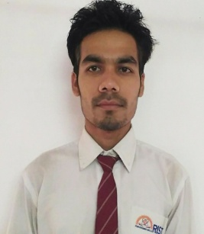**CURRICULUM VITAE**

Name: NILUTJWAL SAIKIA

Email address: [nilutjwalsaikia27@gmail.com](mailto:nilutjwalsaikia27@gmail.com)

Phone number: 8822147310 / 700267249

**Objective:** I would like to be a part of an organisation where I could enhance my knowledge and talent for the development of both the organisation and myself.

**Academic Qualification:**

|  |  |  |  |  |
| --- | --- | --- | --- | --- |
| COURSE | INSTITUTE | BOARD/UNIVERSITY | YEAR Of PASSING | PERCENTAGE/  CGPA |
| B.Tech.  (MECHACAL)  H.S.  H.S.L.C. | Regional Institute Of Science And Technology  Dibrugarh Govt. Boys’ Higher Secondary School  Dibrugarh Govt. Boys’ Higher Secondary School | North Eastern Hill University (NEHU)  AHSEC  SEBA | 2018  2011  2009 | 6.41  60.8%  52.5% |

**Project:**

**Mini Project**: A theoretical study about the design and working of a “Pedal Operated Air Compressor.”

**Major project**: Design and development of the “Pedal Operated Air Compressor”.

**Training and internship:**

* A detailed study of the refiners division of Indian Oil Corporation

Limited, Noonmati, Guwahati.

* A detailed study of the mechanical recovery, paper machine, pulp mill

Departments in Hindustan Paper Corporation Limited, Jagiroad.

**Work experience:** Presently working in T.K. Engineering Consortium Pvt. Ltd. (Naharlagun, Arunachal Pradesh) as a Mechanical GET from 22th of December 2018 to till.

EMP. CODE-17628

**Responsibility**

* To carry out the periodic maintenance, preventive maintenance and breakdown maintenance of all the plants and equipment used in a construction company.
* To allocate mechanical staffs according to their skills and knowledge leading to a team management and team work.
* Monitor everyday work in the form of record.
* To prepare all the reports of the plants and machineries every month.
* Installation and commissioning of a plant.
* Maintain all data as form of records.
* To update with the inventory.
* To indent the spares and equipment according to their requirement.
* To prepare the monthly utilization report, equipment productivity report and other reports of all plants and equipment at the end of every month.

**Professional Proficiency:**

**Certificate Courses-**

• One year diploma course in Advance Diploma in Computer Application

• Workshop on Robotics

• Workshop at “CCSU School on Recent Trends and Development in

General Relativity and Cosmology.”

**Personal Details:**

Date of Birth: 26-01-1993

Language Proficiency: Assamese, Hindi, English

Address: Milan Nagar, J- Lane, Natun Chiring Gaon, P.O- C.R Building

District- Dibrugarh, State- Assam, Pin- 786003

**Declaration:** I hereby declare that all the above information is true to the best of my knowledge.

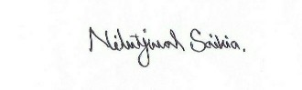

Place: NAHARLAGUN (A.P.) Date: 13-08-209 Signature