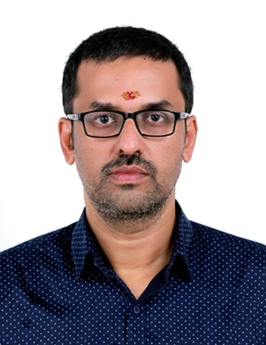 | G.Venugopal  B.Tech (Mechanical Engineering)  Govt. Engineering College, Thrissur  1993, 70%
“Vrindavanam,” Anappara, Ramavarmapuram(P.O), Thrissur-680631  Mob:9446415165  Email:venugopal.girijan@gmail.com | DOB:03-11-71
Current Professional Status
Conducting Math tutoring for students up to 12 th grade for the last 18 years, set up at my own home. Never a teacher by any standards and in fact teaching is something I have never enjoyed. But, my passion for Math is never ending. It is a thrill to deal with the subject. That has given me immense intellectual satisfaction and that has driven me this far for almost last 21 years. To settle in Kerala with a simple life was my dream right after my education. All these merged to become what I am now.
Running online tutoring also for the last 9 years. From 2010 to about 2015, was mostly taking classes for US students. Now dealing more with CBSE Indian students.
Other Experiences
2010-2014 : As a Math home tutor for a company called Growing stars conducting online tutoring for US students.

2008-2009 : Associated with C-Faise, an institution conducting courses in Fire and Safety Management. Was State coordinator of their courses, managing the institutions all over Kerala. But my original association with Math was still continuing during evenings after the office timings.

2000-2002 : Has worked as a Math Teacher in a school called Salsabeel at Mundur, Thrissur.

1995-1997 : Was a Purchase Engineer at Dubai in a firm called Indeset Trading and Decorations, a sister concern of Shobha Developers. Managing the purchase department for their projects run in UAE.

1994-1995 : Has worked as an Apprentice Trainee in GKW, Bangalore.

