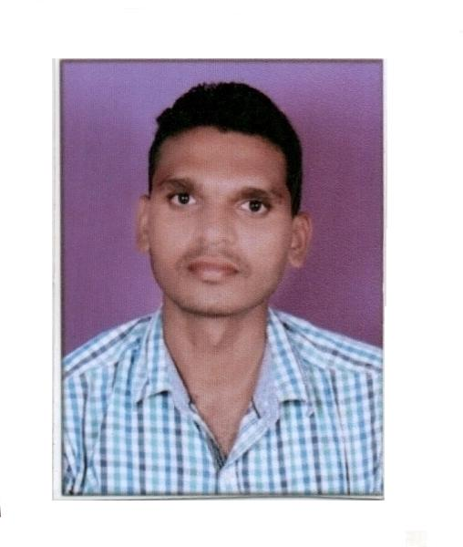
Bijesh Kumar Mohabe
LALKOTHI, SAGAR DHAM COLONY
NEAR GAUR MARRIAGE GARDEN
VIDISHA ROAD BHOPAL (M.P) 462037
Mob: 7047753151, 8120126910.
Email: bijesh.mohabe@gmail.com

CAREER OBJECTIVE
To be part of an organization that is challenging and offers scope for business and quality knowledge development. I wish to extend all my efforts to the growth and development of the organization through creative and innovative ideas.

EMPLOYMENT Summary
- Ramani Ice Cream Company Ltd (RICL Bhopal) Store Executive from June 2017 to 23-April-2020.
- Narmada cereal Pvt. Ltd Bhopal (mandideep) Store In charge from Aug, 2014 to June 2017.
- Thyrocare Technologies Ltd (Navi Mumbai) Executive (Logistics and Purchase) May 2012 to May 2014.
--------------------------------------------------------------------------------------------------------------------------------------
KEY PROJECTS HANDLED:

Executive- Store (RICL)

- Maintain records of material inward & outward.
- Maintain records of daily material issue department wise.( electrical, maintenance, Freon, refrigeration etc.)
- Maintain minimum & maximum stock level of material.
- Physical inventory of material on Weekly & monthly basis.
- Preparing Purchase requisition, RGP, NRGP for material.
- Working on SAP (new material creations, purchase requisition, transfer posting, stock overview, GRN, etc.)
- Preparing daily report of material inward, outward, issue in SAP & sent to Reporting authority (Sr.Manager).

In charge – Store +(Narmada)

- To maintain daily work sheet.
- To maintain records of machinery spare parts (shortex, elevators, conveyer, printing machine and packing machine etc.)
- Purchase machinery Spare parts like jali, gears, chain spocket, husk rubber roll, nut bolt. Elenky bolt, patta bolt, elevator bucket, roller chain, grader pulli, etc.
- Stock taking finished material and packing bags.
- Maintain records of daily production and supervise for the same.
- To take care cleaning of plant and issue material as per requirement.
- Vehicle loading and unloading and maintain records for the same.

Executive- Logistics (Thyrocare).

- To maintain day to day activities of dispatches.
- To coordinate with Customer/Clients as per their needs
- Stock taking & inventory management.
- Courier booking & provide specific documents at the time of booking.
- Courier follow up, shipment tracking & status up dation.
- Vendor co-ordination and service detail update as per availabili
- Invoicing & payment against purchase.

Management Training
- 45 Days Industrial training in Montage Enterprises Pvt.Ltd. Malanpur Gwalior as a management trainee.
Summer Internship
- Two months summer internship in Contrans Shipping Pvt.Ltd. New Delhi.

ACADEMIC QUALIFICATION

PGDM (Post Graduate Diploma in Management)
- PGDM in Tourism & Travel and Basic Air Cargo IITTM, Gwalior (2012) 54.53%.

BBA (Bachelor of Business Administration)
- BBA in Human Resource Management, Jiwaji University Gwalior (2008) 63.44%.

- H.S.C (12th) in Commerce Madhya Pradesh Board (2005) 66.44%.
- S.S.C (10th) in common subjects Madhya Pradesh Board (2003) 50%.
I.T.SKILL

- Operating System : Windows 98, xp,7
- Applications/Software: MS-Word, Excel, Power Point.
- SAP (MM MODULE, MIGO, MMBE, MB51, MB52, ME5A, ZPRPRINT ETC.)
PERSONAL DETAIL
Father’s Name : Mr. D. Mohabe
Date of Birth : 07th Dec.1987
Languages Known: Hindi & English.
Gender : Male
Marital Status : married
Nationality : Indian
Hobbies : Listening to Music, Traveling, Surfing Internet, Playing and Watching cricket.

I hereby declare that information furnished above is true to the best of my knowledge and belief
Date:
Place: Bijesh Mohabe

