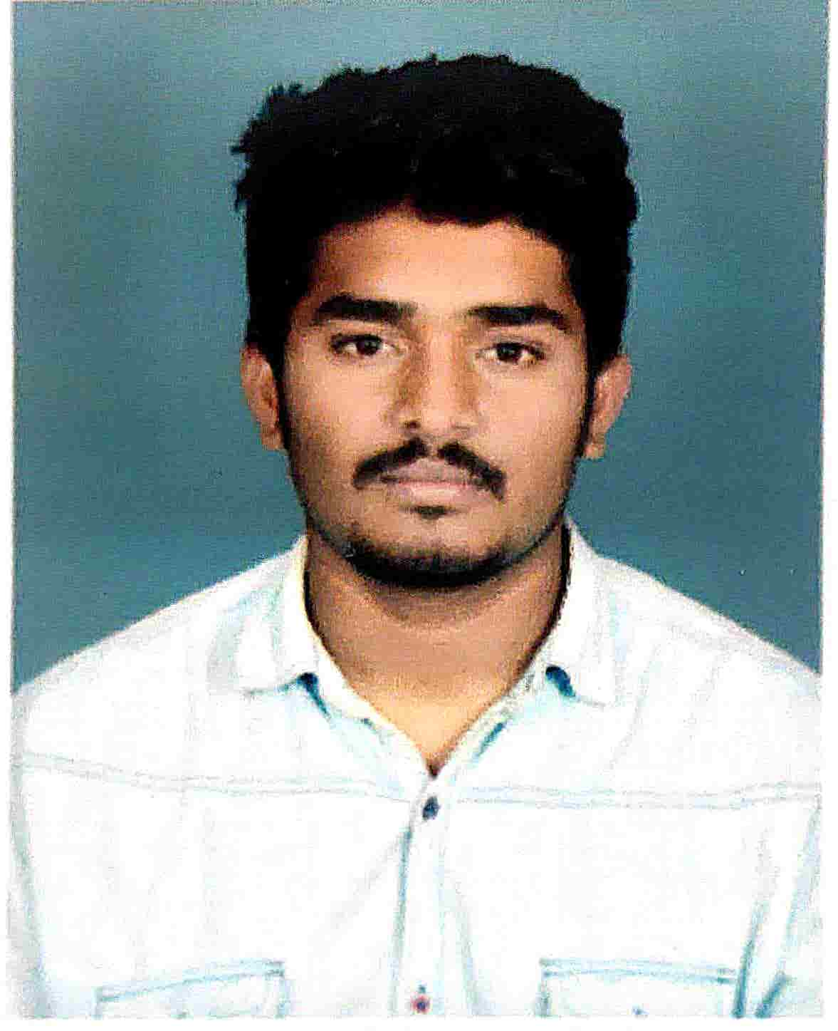

Pratham Prakash Marakatti
Plot no.22 Sy.No. 80, Cross no 2 Maruti nagar
Belgaum - 590016

Email id : pratham.marakatti29@gmail.com
Contact No: 9591027461

CAREER OBJECTIVE: To succeed in an environment of growth and excellence and earn a job which provides me job satisfaction and self development and help me achieve personal as well as organizational goals.

ACADEMIC QUALIFICATION:
Course | Institution | Board/  University | Year of Completion | Percentage
B.E  (Branch) | Jain College of Engineering Belgaum  (Mechanical Engineering) | VTU | 2021 | 56%
Diploma  (Mechanical engineering) | R.N SHETTY POLYTECHNIC  Belgaum | PUC | 2017 | 70%
X | St.Xavier’s High School Belgaum | CBSE/Karnataka | 2015 | 70.24%

TECHNICAL SKILLS:
- Basic knowledge of programming language : 1: C Programming
2: Python

- Designing Software 1: CAED (Computer Added Engineering Drawing)
2: CAMD (Computer Added Machine Drawing)
3: SolidEdge
4: Solid works
5: Catia

AREA OF SPECIALIZATION:
- Specialized in : 1. CAED
2. CAMD
3. AutoCadd
4. Solid works
5. Catia
\\\

CERTIFICATION:
- AutoCadd
- Solid Works
- Catia

STRENGTHS:
- Self-confident and positive thinking.
- Punctual.
- Ability to handle situations in all circumstances.

PERSONAL DETAILS:
- Father’s Name : Prakash
- Date of Birth : 25 December 1998
- Languages Known : English, Kannada, Hindi and Marathi
- Hobbies : Drawing, Singing, Designing and Gaming

DECLARATION:
I, _Pratham Marakatti_ do hereby confirm that the information given above is true to the best of my knowledge.

Place : Belagavi (Pratham Marakatti)

