**PDEVAN SINGH**

Ashok Vihar, Phase 2, Gurgaon

8802599517 | Devanrajawat3161@gmail.com

**EDUCATION**

# Maharishi Dayanand University Rohtak Haryana

Bachelor Of Business Administration

60%

# Board Of School Education Haryana

Senior secondary

75%

**EXPERIENCE**

**Web Data System 1Year As Computer operater**

# Radical Minds Technology Pvt Ltd 6month As CCE

## TECHNICAL SKILLS

Computer knowledge

All Basic Computer operation

Knowledge of Ms Excel

## ACHIEVEMENTS & AWARDS

24th AIKF National karate championship, Aurangabad Silver Madelist

3rd Delhi State Martial Arts Championship 2010

## INTERESTS

Learning New Things

Internet Surfing

**PERSONAL STRENGTHS**

Word Hard

Quick Learner

## PERSONAL PROFILE

Date of Birth : 11/04/1996 Marital Status : Single Nationality : Indian

Known Languages : Hindi, English

Hobby : Bike Ridding

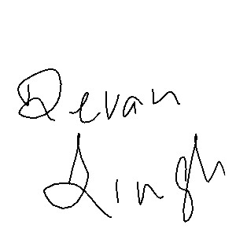

**DEVAN SINGH**