RESUME 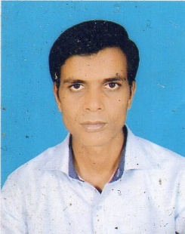

SANDEEP KUMAR PANDEY

ADD : Village-Gothwan

Post - Gothain

Pin code - 221711

District-Ballia

Mobile:09984222951

E.ID - sandeep.pandey196@gmail.com

***CAREER OBJECTIVE****:*

TO obtain a challenging and responsible position in the organization and to serve

it With diligence competence honesty by delivering by best performance.

***EDUCATION QUALIFICATION***

High School From U.P. Board in 2001 (47%)

Intermediate From U.P. Board in 2004 (57%)

Graduation From V.B.S.Purvanchal University Jaunpur in 2008 (42%)

***PROFESSIONAL QUALIFICATION***

ONE YEAR COMPUTER COURSE (DATA ENTRY)

***PERSONAL DETAILS***

Date of Birth : 25/07/1986

Father Name : Mr. UMASHANKAR PANDEY

Mather name : Mrs. RADHIKA DEVI

Nationality : INDIAN

Marital Status : MARRIED

Gender : Male

Languages Known : Hindi & English

***DECLARATION***

I hereby declare that all the information submitted here in is correct to best of

my knowledge and belief.

Date:…………………

Place:……………….. (SANDEEP KUMAR PANDEY)