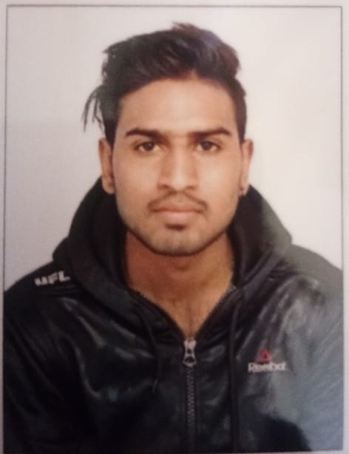

**Resume**

Name: Abhishek Prasad

Contact no: 8256905223

Email ID: abhishekprasadgupta567@gmail.com

ADDRESS:

***Address :- Umpling lumdeingmet near bsf petrol pump***

CAREER OBJECTIVE:

I intend to build a career with a leading corporate with committed and dedicated people, which would help me to explore myself fully, realize my potential and to work as a key player in a challenging and creative environment.

EDUCATION QUALIFICATION:

S.S.L.C- (2015)

H.S.L.C –(2017)

OTHER QUALIFICATION:

* Computer Knowledge

Begginers

Intermediate

DTP

PERSONAL SKILL:

* I can adjust with any situation wherever comes in my way.
* I have a positive attitude.
* Overcome challenges.

WORKING EXPERIENCES:

* Freshers

LANGUAGES KNOWN:

* ENGLISH
* HINDI
* NEPALI

PERSONAL DETAILS:

* NAME : ABHISHEK PRASAD
* FATHER’S NAME : Lt.AchelaPrasad
* DATE OF BIRTH : 21-11-1998
* MARITAL STATUS :UNMARRIED
* RELIGION : HINDU
* NATIONALITY : INDIAN
* SEX: MALE
* CASTE: GENERAL

DECLARATION:

I do hereby declare the above furnished information is true to the best of my knowledge.

Place:

Date:

aprasad

Signature of the

Applicant