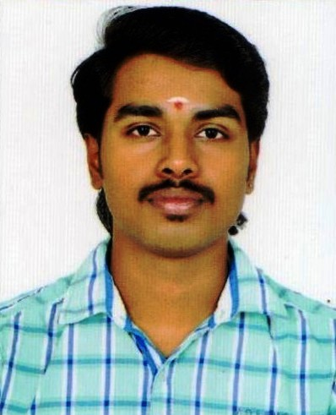

BALAKRISHNAN K G
Mobile No:9538064808
Email id: balakrishnanpallippattu95@gmail.com

Career Objective

- Seeking a carrier in a well-established company that offers ample opportunities for professional growth by utilizing my full potential. Being a dynamic and motivating personality with excellent communication skills, good leadership quality and high grasping power, I am confident that I would be able to add value and contribute immensely to the organization

Educational Qualifications:-

- SSLC (2010 -2011)
- +2 COMMERCE (COMPUTER APPLICATION) (2011 – 2013)
- BCOM (COMMERCE) 2020

WORK EXPIRIENCE: -

- Junior Accountant (Venus Digital Arcade) from June 1st 2013 TO AUGUST 31ST 2014.
- Apollo Health & Life Style Limited (Business Development Executive) from Feb 13nth 2017 to 6th April 2019.
- Aster RV hospital a unit of DM Health Care PVT LTD (ASSOCIATE CUSTOMER CARE) from 03 OCT 2019 still working.

Personal Skills: -

- Ability to learn quickly, team co-ordination, hard working

Linguistic Abilities:-

- English (Read, Write & Speak)
- Malayalam (Read, Write & Speak)
Kannada (speak)
- Telugu (speak)
- Hindi (Read, write)

Extra – curricular activities:-

- Hobbies : Listening Music, Drawing, Night Driving.
- Games : Cricket

Personal Profile:-

Date of Birth : 26/6/1995
Age : 25
Sex : Male
Marital Status : Single
Nationality : Indian
Present Address : BALAKRISHNAN
S/O GOPINATHAN K
PALLIPPATTU HOUSE
MUNDUR POST, KIRALOOR,
THRISSUR, KERALA - 680541

E-mail Id : balakrishnanpallippattu95@gmail.com
Phone Number : 9538064808

Declaration:-

I hereby acknowledge that the above given information are true to the best of my knowledge and belief.
Date:
Place: BANGALORE

