**Career Objective:**

“Seeking an opportunity to utilize my skills in serving in an organization to the best of my knowledge and hoping to play an inventive and active role in the organization growth of technology”.

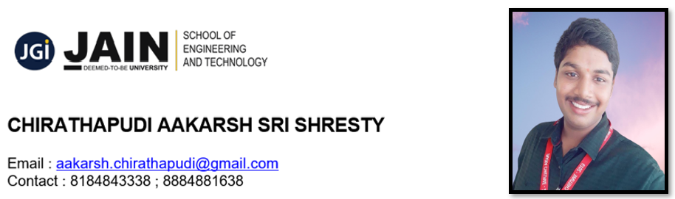.**Educational Qualifications:**

|  |  |  |  |  |  |
| --- | --- | --- | --- | --- | --- |
| Qualification | Specialization | Institution &  Place | Year of Passing | Board / University | Percentage  (%) |
| BTech | Electronics and Communication Engineering  ( ECE) | Faculty of Engineering and Technology- Jain(Deemed-To-  Be-University), Bengaluru | 2021 | Jain  University | *73.7 % |
| 12th Std. | Mathematics, Physics,  Chemistry.  (M.P.C.) | Sasi Junior  CoIIege, Velivennu | 2017 | Andhra Pradesh Board of Intermediate Education.  ( AP – BIE) | 94.4% |
| 10 th Std. |  | Bharatiya Vidya Bhavan’s Residential Public School, Tadepalligudem. | 2015 | Central Board of Secondary Education.  (C.B.S.E.) | 94.0 % |

*Percentage upto 7th Semester

**SUMMER INTERNSHIP / WORK EXPERIENCE :**

1. **GRADBOSS**  ( Web Designer) Jan 2021 - Present Bangalore, Karnataka
2. **BSNL** ( Industrial Telecom Training) Jul 2020 - Aug 2020 Hyderabad, Telangana
3. **BOLT** (IoT Devices and Applications) May 2019 - Nov 2020  Bangalore, Karnataka

**TECHNICAL PROFICIENCY AND TOOLS EXPOSED:**

Antenna Design, Deep Learning, LabVIEW, Bitcoin, Machine Learning, anaconda, C

Programming, Telecom Technologies, Internet of Things, Blockchain, Arduino UNO, Atom, Application Development, Web Technologies: HTML, Biomedical Electronics, Web Development, Amazon Web Services (AWS), Simulink, Python, PSpice, Java, TINA Software, HTML, MATLAB, Cadence Virtuoso, AutoCAD, Virtuoso, Eclipse, Code Blocks

**VOLUNTEERING EXPERIENCE:**

1. Campus Ambassador **– Gradboss** – January 2021
2. Campus Ambassador – **Verzeo** – August 2020
3. Campus Ambassador – **Internshala**- January 2018

##### **POSITION OF RESPONSIBILITIES:**

#### Student Placement Cell Coordinator - ECE - Aug 2020 – Present

#### Member of Student Information – ECE - Mar 2020 – Present

#### NSS – ECE – Student Incharge - Apr 2019 – Present

#### Library Student Coordinator – ECE- May 2018 - Present

**MINI PROJECTS:**

1. 69th IIRS-ISRO Outreach program on GNSS - Networking
2. 50th IIRS-ISRO Outreach Program On Basic of Remote Sensing ,GIS and GNSS - SATELLITE SYSTEMS : RS, GNSS, GIS
3. 38th IIRS-ISRO Outreach Program On Global Navigation Satellite System and Geographical Information System – Satellite systems : GNSS, GIS

**PROJECTS:**

1. Basic Safety Peripheral Device.
2. Biomedical Signal Processing Device using ICA Algorithms.
3. Biometric Authentication for Cars
4. Solar Cell Android Mobile.

**PUBLICATIONS:**

1. National Conference "Jnana Chilume" 29thMarch, 2019  Published an Article on BIO MEDICAL SIGNAL PROCESSING USING ICA ALGORITHMS AND FILTERS.

**CERTIFICATIONS:**

1. Java Programming – Udemy
2. Fundamentals of Python Programming – Internshala
3. Bio Medical Signal Processing - Nptel

**COMPETETIONS:**

1. National Conference – JNANA CHILUME – March 2019 – Jain University
2. Prerana- May 2019- Gitam University Bangalore
3. Shaastra –January 2020- IIT – MADRAS
4. Pragyan - March 2020- Gitam University Bangalore
5. National Conference – JNANA CHILUME –November 2020 – Jain University

**CONFERENCES:**

#### Shaastra 2020 - Organized by IIT Madras -Jan 2020

#### National Conference 2020 - Organized by Jain University- Nov 2020

#### National Conference Jnana Chilume - Organized by Jain University- Mar 2019

#### Aero Aviation Workshop - Organized by IISC - Jan 2020

#### Under 25 Summit- Organized by IEEE - Mar 2020

#### Prerana 2019 - Organized by Gitam University - May 2019

#### Pragyan 2020 - Organized by Gitam University - Mar 2020

#### Machine learning through python - Organized by IIT Madras Anaconda - Jan 2020

#### Deep Learning through matlab - Organized by Mathworks, IIT Madras - Jan 2020

**PERSONAL DETAILS:**

Date of Birth : 27/10/1999

Gender : Male

Language Known : Telugu, English, Hindi, Kannada, Sanskrit

Hobbies : Singing, Dancing, Playing, Drawing, Travelling, etc..

Permanent Address : 9-71 , Velampeta , Ganapavaram, Ganapavaram Mandal, West Godavari District,Andhra Pradesh  
Eluru, Andhra Pradesh, India, 534198

Marital Status : Single

**DECLARATION:**

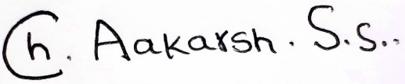I hereby declare that the above given information is true and correct to the best of my belief and knowledge.

Place: Bangalore ( CHIRATHAPUDI AAKARSH SRI SHRESTY)