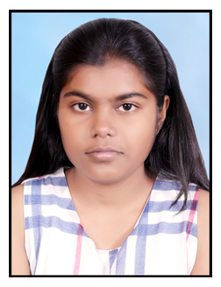

MARYLINE BAPTIST
Phone No. (P) 08690617810
Email: marylinebaptist8@gmail.com

- Name:- :Maryline Baptist
- Date of Birth :21st September 2001
- Residential Address : House No. 42 Near Street No 2, Saraswati Nagar Dhola : Bhatta, Road, Ajmer (Rajasthan) 305001
- Father Name : Mr.Sanjay Baptist
- Gender : Female
- Nationality : Indian
- Marital Status : Unmarried
- Language Known : Hindi & English
- Religion : Christian (Roman Catholic)
- Education Qualification : XII th Science (Bio)

Place:-Ajmer

MARYLINE BAPTIST

