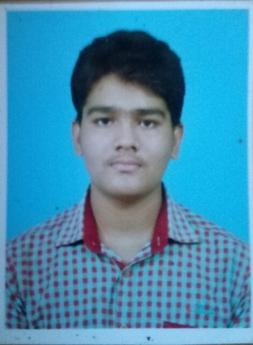
HARIHARAN.R
No 1\1,
Ruby flats,
Thungabathra street,
Madipakam,
Chennai-600 091.
Email:hariharan130897@gmail.com
Contact no:-+919094943513

PROFESSIONAL OBJECTIVE:
To effectively utilize my skills in the field of engineering for the development of myself and for the company in which I am working with utmost dedication. ACADEMICACADEMICRECORD
ACADEMIC QUALIFICATIONS:
Course | Institution | Board/  University | Year of  Completion | % of Marks  / CGPA
B.E(Mechanical Engineering) | Velalar College of Engineering  and Technology,  Erode-638012. | Anna University,  Tamil Nadu. | 2019 | 64.6%
HSC | KSR Matric Higher Secondary School, Tiruchengode-637215 | Matriculation,  Tamil Nadu. | 2015 | 85.67%
SSLC | KSR Matric Higher Secondary School, Tiruchengode-637215 | Matriculation,  Tamil Nadu. | 2013 | 93.6%

COMPUTER SKILLS:
- Software Known: Auto CAD, CREO.
- Languages: Basics of C , C++.

AREA OF INTEREST:
- Automobile Engineering
- Manufacturing Technology
ACADEMIC ACHIEVEMENTS:
PROJECT AND WORKSHOP:
- Participated in a Workshop “SPYBOTICS” Conducted by i3indya Technologies at SASTRA UNIVERSITY , Tanjore on 24-02-2017 & 25-02-2017.
- Presented project on “MINI MOTOR CYCLE USING WASTE SCRAP MATERIALS” at VELALAR COLLEGE OF ENGINEERING AND TECHNOLOGY, Erode on 10-03-2017.
- Participated in a Workshop “ADVANCEMENTS IN AUTOMOBILES” Organised by SAEINDIA SKCET at SRI KRISHNA COLLEGE OF ENGINEERING AND TECHNOLOGY,Coimbatore on 15-09-2017.
- Participated in State level Engineering Graphics Contest “E-DRAFT ’15” at ADITHYA INSTITUTE OF TECHNOLOGY, Coimbatore on 14-11-2015.
- Participated in inter-department Paper Presentation held at VELALAR COLLEGE OF ENGINEERING AND TECHNOLOGY, Erode.
INDUSTRIAL VISIT:
- Undergone Industrial visit at “SAKTHI AUTO FOUNDARY”, Perundurai .
- Undergone Industrial visit at “ ANNAMALAYAS PVT. LIMITED”, Pollachi on 18-02-2017
- Undergone Industrial visit at“ METTUR HYDRO POWER PLANT and METTUR THERMAL POWER PLANT”, Mettur on 16-08-2017.

PROJECT DETAILS:

Title: Design and fabrication of
Description: By this project, used to experimental study carried out to determine the performance of a domestic refrigerator when liquified petroleum gas is locally available and cause no ozone depletion and no Global warming potential.
MEMBERSHIP ACTIVITIES:
- Active student member of Indian Institute of Production Engineers (IIPE) from
03-09-2016.

PERSONAL INFORMATIONS:

FULL NAME | : | HARIHARAN.R
DATE OF BIRTH | : | 13-08-1997
GENDER | : | Male
FATHER NAME | : | Mr.RAMACHANDRAN.S
PRESENT ADDRESS | : | No 1/1,  Ruby flats,  Thungabathra street,  Madipakam,  Chennai-600 091.
NATIONALITY | : | Indian
LANGUAGES KNOWN | : | Tamil, English (Read, Speak, Write)
HOBBIES | : | Driving, Listening Songs, Playing, Reading Books.
STRENGTH | : | Punctual, Optimistic, Honest, Adaptive to New Environment.

DECLARATION:
I,here by confirm that the information given above is true to the best of my knowledge.

Place: Thindal-12 Yours Sincerely,
Date: (HARIHARAN.R)

