CURRICULUM VITAE

Mohit Kumar Saini
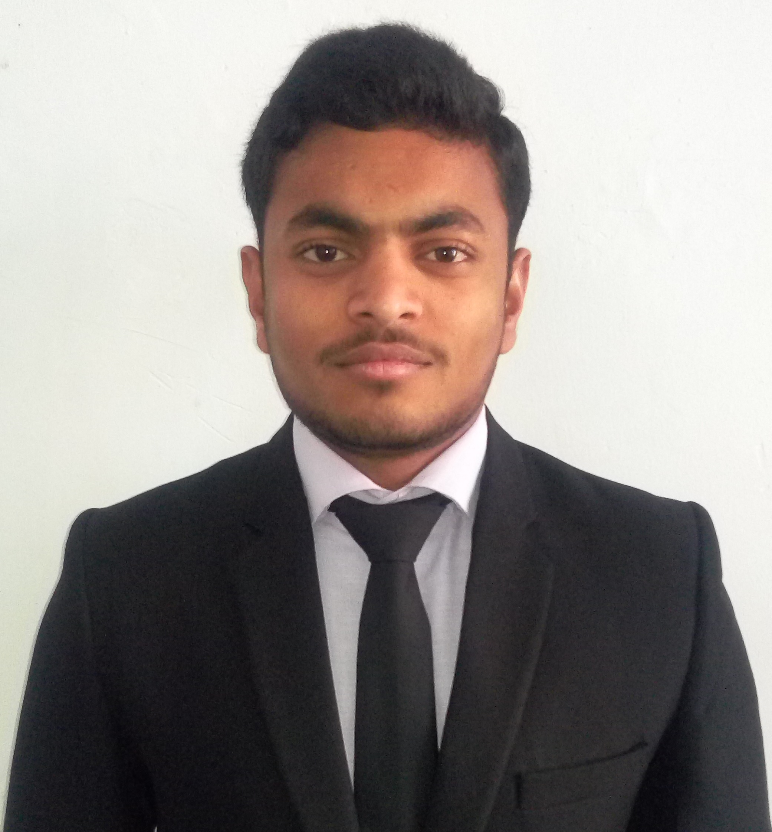
B-16 CISF camp Indirapuram, Ghaziabad, U.P
Pin Code – 201014
LinkedIn : www.linkedin.com/in/mohit-kumar-saini-76b593128/
Email : mohitkumarsaini23064@gmail.com
Phone No: 6280069687

CAREER OBJECTIVE

To secure a challenging position where I can effectively contribute my skills as a cyber security professional possessing competent technical skills.

EDUCATIONAL QUALIFICATIONS

Degree / Certificate Institution/ Board Year CGPA / Percentage
B.Tech (CSE) Lovely Professional University 2020(Pursuing) 8.25 – VII Sem
Phagwara, Punjab
SSC Kendriya Vidyalaya 2015 72.4%
Ghaziabad, U.P
HSC Kendriya Vidyalaya 2013 76%
Ghaziabad, U.P

TECHNICAL SKILLS

Tools : Nmap, Wireshark, Metasploit, John the ripper, Burp suite, ZAP etc.
Languages : C, C++, Python, Bash script, Java, C#.
OS : Windows, Linux.

PROJECTS UNDERTAKEN

Letshopping.com Feb 2020-April 2020
- .NET, C#: This was an E-commerce website which used to sell and by electronic product. We made it secured website by protecting from OWASP top 10 vulnerability. Admin Task, User Login, Sign in, Product Order, Profile, Product Database.
Nivedayati March 2019-Nov 2019
- Web application: This project shows the crime rates, missing person and missing vehicle of selected area on geographical map. These falls under the category of security and surveillance.
Pizza Hut February 2017-March 2017
- Management system: The project was to develop management system program for menu and print bill according to given instruction.
Learning Management System February 2017-March 2017
- Web Page: The project was to design a web page for learning management system.
Aadhaar Card September 2016-November 2016
- Person Details: The project was to input and show the details of Aadhaar card holder.

CERTIFICATIONS/ COURSES

- Completed specialization “IT Fundamentals for cybersecurity” by IBM on Coursera, May 5, 2020.
- Completed CompTIA security+ training.
- Completed course “Ethical hacking” on NPTEL, November 16,2019
- Completed course “Cybersecurity and Mobility” by University System of Georgian on Coursera. Certificate earned at Friday, March 8, 2019.
- Completed “Intro to Python” training course provided by Cybrary. Certificate earned at Saturday, January 12, 2019. 
- Completed “Cryptography” training course provided by Cybrary. Certificate earned at Tuesday, August 28, 2018.
- Completed course “Cryptography I” by Stanford University on Coursera. Certificate earned at Sunday, July 8, 2018.
- Completed course “Introduction to Cyber Attacks” by New York University Tandon School of Engineering on Coursera. Certificate earned at Sunday, July 1, 2018.
- Completed course “Fundamentals of Red Hat Enterprise Linux” offered by RedHat on edX. Certificate earned at Sunday, June 17, 2018.

WORKSHOPS /SEMINARS

- Attended seminar on “Cyber security & Ethical Hacking” by Palvinder Singh CEO & founder of Secuneus Tech. at Lovely Professional University on March 29, 2019.
- Participated in five Day workshops on “Git & Version Control” by Microsoft at Lovely Professional University in September 2017.
- Attended seminar on “Microsoft Imagine Talks” by Microsoft at Lovely Professional University on September 16, 2017.

EXTRA CURRICULAR ACTIVITIES

- Participated as student volunteer in Annual Mega Event “Explorica-Exploring Young Talents” in Lovely Professional University
- Discuss and Awareness in people about water bodies in Cheharu, Punjab.
- 2 month working experience in call center of Vodafone company as an executive.
- Participate in football match (defender) in schooling.

AWARDS AND HONOURS

- Scholarship awarded by Prime Minister. May 2019
- Awarded 3rd Prize in 100m sprint organized by CISF. June 2017

LANGUAGES KNOWN

English, Hindi

HOBBIES

Playing Football, Watching Movies

PERSONAL DETAILS

Father’s Name : Mr. Babu Singh Saini
Mother’s Name : Mrs. Pinki Rani
Date of Birth : 12-06-1997
Gender : Male

