# **RESUME**

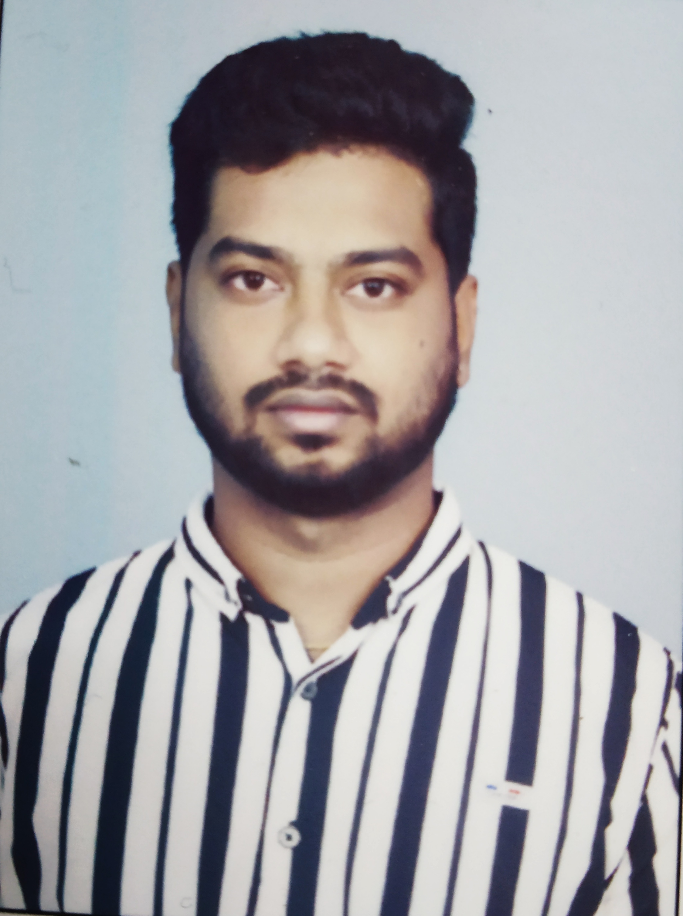

**JAYENDRA KUMAR KM**

**Address for correspondence:**

**4/178, Anthoniar nagar,**

**Ganeshapuram,S.S Kulam(via),**

**Coimbatore-641107.**

**Phone : +918870132963**

**Email id : jayendran619@gmail.com**

**Career Objective:**

To obtain a job where I can apply my extensive skills and knowledge to the growth and expansion of the esteemed organization.

### **Academic Excellence:**

|  |  |  |  |  |
| --- | --- | --- | --- | --- |
| **Course** | **Year of**  **completion** | **Institution** | **Board** | **Percentage/cgpa** |
| b.e/ece | 2017 | info institute of engineering | anna university | 6.56 |
| 12th | 2013 | K.G Matric Higher Sec. school | state board | 87.83 |
| 10th | 2011 | St.Antony’s Matriculation School | matriculation | 90.4 |

### **Co-curricular Activities:**

* A member of an NGO named Happy Hearts.
* An organizer in Daya 2k14 and 2k16 conducted in Info Institute of Engineering.
* A member of Rotaract club of Info Institute of Engineering, Coimbatore.

**Hobbies :**

* Playing football and volleyball
* Cooking
* Food travelling.

**Personal Skills:**

* Ability to learn and adapt.
* Posses interpersonal and presentation skills.
* Good communication skills.
* Works well under pressure.
* Problem solving and time management.

**Experience:**

* 7 months as a Market research analyst – Trainee (Contract) in Owler India Pvt. Ltd.
* Currently working as a Customer Service Associate in Amazon Development Center (1 year 8 months).

**Personal Information:**

Father’s Name : N. Mohanraj

Mother’s Name : M. Parameswari

Date of Birth : 20/01/1996

Gender : Male

Nationality : Indian

Religion : Hindu

Languages Known : Tamil, English

Native : Coimbatore

Date - 27/01/21  
Place - Coimbatore

Faithfully,

Jayendra Kumar. KM