BIO-DATA
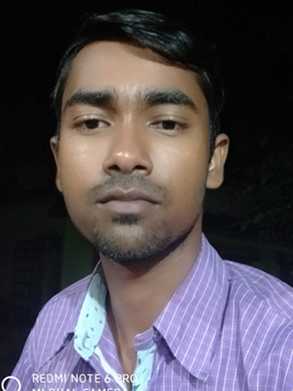
PHOTO

Name : JULIAS MANDAL

Father’s name : SANYASI CHARAN MANDAL

Mother’s name : SUBASINI MANDAL

Permanent address : AT/PO-KASAFAL,VIA-LANGLESWAR,
P.S-SINGLA,DIST-BALASORE,PIN-756024

Contact No. / Mobile : 9114665578,9439500325

Home Phone : 9861540693

Date of birth : 12/03/1993

E-mail : juliasmandal08@gmail.com
CAST : SC
Religion : HINDUSIM

Nationality : INDIAN

Marital status : UNMARRED
Education qualification :
Name of exam | Year of passing | Board/university | Division/Percentage
10th | 2008 | BSE,ODISHA | FIRST[83.62]
^{+2SCIENCE} | 2010 | CHSE,ODISHA | SECOND[58.00]
Bsc[Forestry] | 2015 | OUAT,ODISHA | FIRST[80.00]

Computer knowledge : PGDCA

Employment Exchange Regd. : NO

Working experience :NO
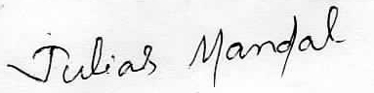

Signature of the Applicant

