
NITIN KUMAR PRAJAPATI

Sr. Account Executive
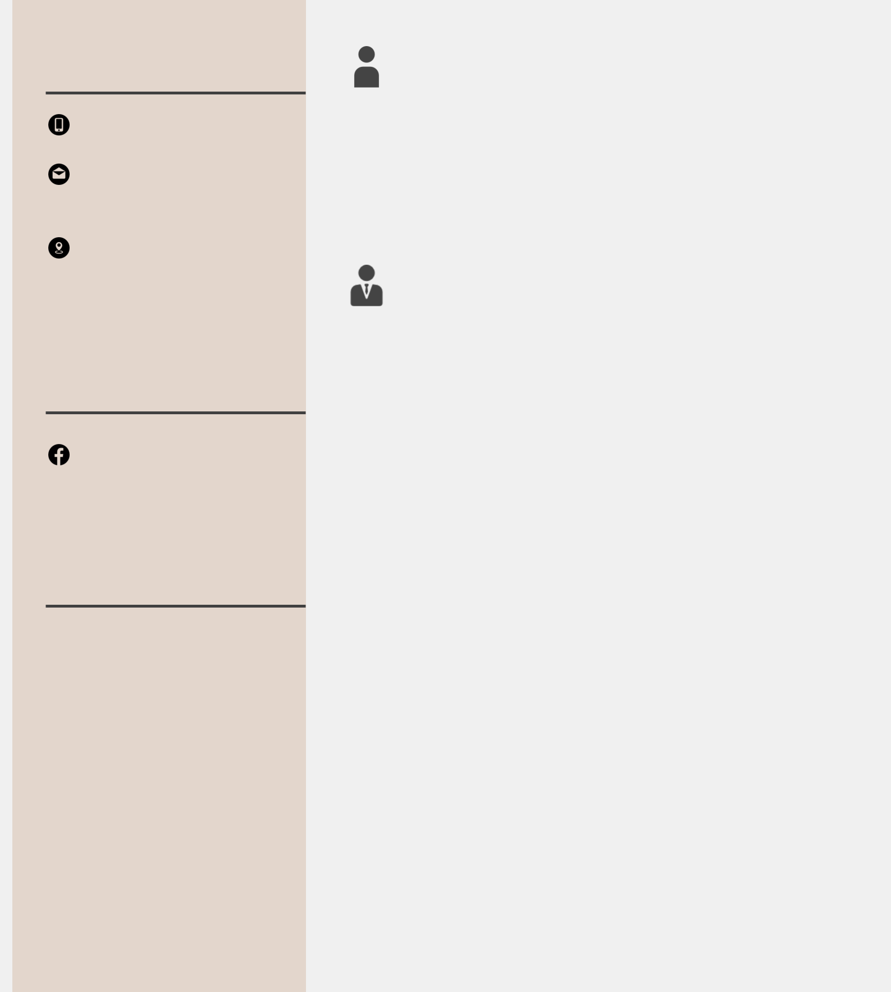

Contact Me

+91-9643245410,7982653017

nitinkumar6819891@gmail.co m

H-188, Sarai Pipal Thala,Adarsh Nagar, Delhi Delhi ,India

Social Profile

facebook.com/nitinkumarpr ajapati

Other Info

Skills

Communication

Ability to Work Under Pressure Decision Making Time Management
Self-motivation

Conflict Resolution

Leadership

Adaptability

Teamwork

Creativity

Oct 2018 -

working

About Me

I am a Inventive, Exciting,Thoughtful, Proactive, Productive, Professional, Achiever, Knowledgeable, Leader, Diplomatic, Logical, Patient, Active

Experience

Alder Furniture Pvt Ltd | Sr. Account Executive

Maintain accounts of company Maintain stock register of company.

Maintain branch accounting and reconcile the Branches on monthly basis
Prepare Profit and Loss report monthly Invoicing of sales and purchase of furniture’s Bank Reconciliation
Issue cheques to vendors and expenses Handle the cheques from customer Maintain Day Book of Company

Prepare debtors and creditors outstanding reports

Invoicing on tally erp

Preparation and filing of GST 3B

File returns of GSTR-1

Reconciliation of GSTR-2a

Deposit TDS on monthly basis

File returns of TDS

Book keeping

Vendor’s Reconciliation on weekly and monthly basis Prepare export documents and credit the LC PF and ESI Monthly payments and file returns

Awards

•6 months course of Tally 9.0 from Saraswati Accountants.
Assist in audits

Handling customers

Financial reporting to seniors

- 6 months D.T.P course from MCEC Institute.

- 8 months Certified Industrial Accountant Course from Institute Of Computer Accountants.

•Knowledge ofGST

•Team handling

Languages

English, Hindi

Interest

Music, Travelling

Oct 2017 - Oct 2018

Indraprastha Automobiles Pvt Ltd | Account Executive

Maintain Trading accounts of company Maintain Stock register of company.

Maintain Branch accounting and reconcile the Branches on monthly Basis
Prepare Loan and Funding Reports of our Mahindra Prepare Profit and Loss report monthly

Invoicing of Sales and purchase of vehicles and accessories

Bank reconciliation on Weekly basis

Issue Cheques to vendors

Handle the Cash and Cheques from customer Maintain Day Book of Company

Prepare Debtors and Creditors outstanding reports Preparation and filing of GST 3B
File returns of GSTR-1 and GSTR-4 Deposit TDS on monthly basis File returns of TDS

Prepare Balance Sheet of our branch

Aug 2013 - Oct K. G. Bearing Pvt Ltd | Account Executive

2017

Prepare invoice on Tally erp 9.0

Prepare Stock register manually

Cash collection from debtors

Payment issued to our creditors

Prepare Debtors and Creditors report

Bank Reconciliation Statement

Maintain purchase register

Maintain Day Book of Company

Maintain books of cash and credit trading

Book Keeping

Calculation and payment of Sales Tax


Education

2011 - 2013 Jodhpur National University | Masters In Commerce

Jodhpur national university people take on audacious problems, bring imaginative new approaches to solving them, and work collaboratively to advance knowledge and make meaningful contributions to our world.

2006 - 2011 Delhi University | Bachelor In Commerce

Delhi university students are very innovative and confident.

May 2004 - May

2006

- May 2004

Govt Boys Sr. Secondary School | Sr. Secondary

students are very innovative and confident of this school.

H.R Green field School | High School

Students of green field school are good in sportsmenship and leadership..


Nitin Kumar Prajapati

