**RESUME**

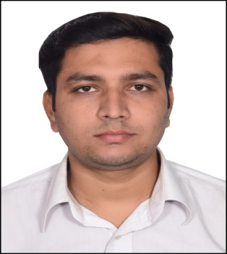

**Name: Kaleem Ahmad Khan**

**House No-53A,**

**Street No-8A,**

**Noor Nagar, Jamia Nagar,**

**New Delhi-110025, India**

**Mobile No: +919818718299**

**Email: kaleem.khan.dbg@gmail.com**

**Profile**

To work in a firm with a professional work driven environment where I can utilize and apply my knowledge, skills which would enable me as a fresh graduate to grow while fulfilling organizational goals.

**Education / Qualification:**

* Bachelor of Civil Engineering from Al-Falah University, Haryana in (2014-2018),
* SSCE from M.K.College, Bihar in (2013),
* SSE from Bihar board, in (2011),

**Employment History:**

Period of Employment : June 2018 to Till Date

Company : **RANJIT BUILDCON LIMITED**

Designation : Junior Engineer (Site work)

Name of the Project : Construction of H.L. Bridge over river Mahanadi on Athamalik To Dholpur Road of Angul/Boudh District in the state of Odisha on EPC Mode under NABARD

Client : **PUBLIC WORKS DEPARTMENT, ODISHA**

Cost of Project in INR : 168.91 Crores

Design Consultant : Shah Associates

Responsibilities:

* Preparation of Daily and Monthly Progress report For client & higher management.
* Making Running account bills (RA BILLS).
* Maintain Request for Inspection (RFI) & Supporting Documents for client and PWD.
* Checking of Reinforcement with the help of drawings before the client checking.
* Oversee construction works for bridge like Pier, Pier cap, PSC Girder, RCC Girder, Slab, Handrails.
* Oversee Gabion Wall And Approch Road works.
* Maintain safety measures and time measures.
* Manpower and Resource management.

Period of Employment : Jan 2018 to April 2018

Company : **CONTINENTAL ENGINEERING CORPORATION**

Designation : Trainee Engineer

Name of the Project : Comprehensive development of Corridor (Outer Ring Road) between Mukarba Chowk to Wazirabad, includes Flyovers, Grade Separators, Bridges, Road widening, Cycle Tracks and etc.

Client : **PUBLIC WORKS DEPARTMENT, DELHI**

Design Consultant : M/s. L&T – Ramboll Consulting Engineers Limited

**Skills:**

* Microsoft Office Word.
* Microsoft Office Excel.
* Microsoft Office Power Point.
* Auto Cad.
* Internet browsing.

**Languages known:**

* English.
* Hindi.

**Personal Details:**

**Name : Kaleem Ahmad khan**

**Father’s Name : Nazeer Ahmad khan**

**Mother’s Name : Yasmeen Khanum**

**Address : Shahganj Benta, Laheriasarai, Darbhanga, bihar-846003**

**Marital Status : Single**

**Sex : Male**

**Date of Birth : 23-01-1997**

**Nationality : Indian**

**Passport : R2461727**

**Declaration:**

I amconfident of my ability to work in a team and assure that I shall deliver my best & ensure the compliance my obligation to work and conduct. I hereby declare that the information furnished above is true to the best of my knowledge.