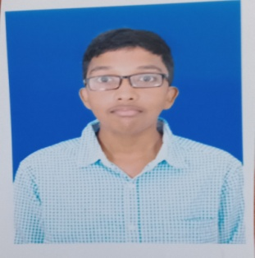

PUDIPEDDI SAI TARUN
12-121 Gajularega rajaveedhi
Vizianagram.Andhra Pradesh.535001
Saitarunpudipeddi1@gmail.com
9391486338

CAREER OBJECTIVE

I would like to be a part of company where I could use and enhance my knowledge for the development of both company and myself.
EDUCATION

- Aditya Degree College
BCA (Bachelor of Computer Applications)
8.1 CGPA ( Upto 3rd Semester)
2021

- Sri Chaitanya Junior College
Intermediate (M.P.C)
65.5 CGPA
2018

- Dr.besant English medium school
SSC Board
7.7 CGPA
2016
TECHNICAL SKILLS

- C- Language
- Java
CERTIFICATION

- Cisco C Learn Certification

PERSONAL INFORMATION

Name : Pudipeddi sai tarun
Father’s Name : pudipeddi durga prasasd
Mother’s Name : pudipeddi padmaja vaidehi
Date of Birth : 07-02-2001
Nationality : Indian
Languages Known : English & Telugu
DECLARATION

I hereby declare that the details furnished above are true and correct to the best of my knowledge and belief.

Date:
Place: Vizianagaram

PUDIPEDDI SAI TARUN

