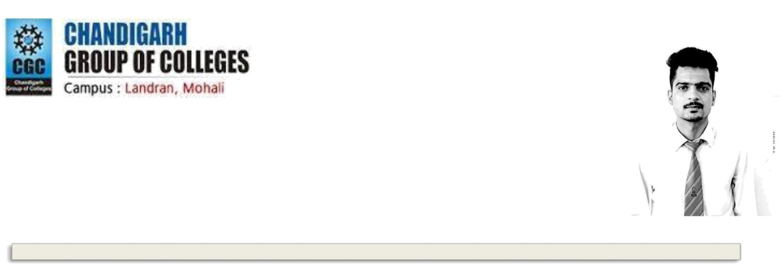

ABHISHEK SIN GH

V.P.O -Baloh , Di st. -Bilasp ur,Himachal pradesh

Pin Code-174 029

+918872115367 abhitkshak06@gmail.com


EDUCATIONAL QUALIFICATIONS

 | Year | Degree | School/Institute |  | Board/University |  | %age /CGPA
 | 2018 | MCA | CGC Chandigarh, |  | Punjab Technical |  | 80%
 |  |  | Engineering college, |  | University
 |  |  | Landran
 | 2015 | B.Sc.(non-med) | Govt.Post Graduate |  | HPU | 62.1%
 |  |  | College,Bilaspur,Himachal |  | SHIMLA
 | 2012 | 10+2 | Govt.Sr.Sec.School |  | HPBOSE | 72.04%
 |  |  | Berthin,Himachal |  | Dharamshala
 | 2010 | 10th | Govt.Sr.Sec.School |  | HPBOSE | 80.6%
 |  |  | Berthin,Himachal |  | Dharamshala

ACADEMIC ACHIEVEMENTS

- Second position in MCA 1st & 2nd sem.

- 103th Merit rank in Himachal in matriculation.

- Participated in “Student parliament” organized by CSE department.

- First position in INTER COLLEGE YOUTH FESTIVAL (IV).

- Second position in POSTER MAKING COMPETITION on World Aids Day.

Work Experience:
Profile Name: Business Development Manager
Company Name : Intime Infotech /RTL pvt. Ltd
Duration: 5 months

Project:
Title: Smart Messenger app.
Technology used : JAVA.
Description: It is a smart messenger light application which enables you to send texts ,pictures ,voice messages up to a short length (Bluetooth range).

SOFTWARE COMPETENCIES

Operating Systems | : | Windows 7, Windows 8,linux,unix
Languages known | : | C, C++,core java
Database(s) known | : | MySQL
Other Interests | : | Software Engineering, Database, Operating System, Testing , QA

- Leadership Quality (a good team leader as well as a team member).

- Ability to listen someone and then giving ideas to him/her.

- Ability to communicate with people in a confident way.

- Ability of Multitasking.

- Ability to Tackle the problems with Positive Attitude and in less time.

EXTRA-CURRICULAR ACTIVITIES

- Organized a wonderful event on “INTERNATIONAL WOMEN’s DAY”.

- “HEAD COORDINATOR” of “JASHAN 2K17”.

- “1ST POSITION” in dance competition during “PARIVARTAN 2K18”.

- Hosted many events like “www Day”, Annual Day Celebration, Teacher’s day.

- “2ND POSITION” in cultural event during “PARIVARTAN 2K18”.

- “1ST POSITION” in “INTER COLLEGE YOUTH FESTIVAL GROUP-4”.

- Participated in Dance competition in “ZEITGEIST” at “IIT ROPAR”.

- Selected as coordinator for “INTERNATIONAL AFFAIRS”,”CULTURAL group, of “MCA DEPT”.

HOBBIES/INTERESTS

- Browsing on internet to get updated with current affairs and issues.

- Dancing ,Acting.

- To know about different cultures of INDIA and other parts of the WORLD.

- Sketching and Story Writing.

- To interact with people to have the discussions on common issues.

- To watch motivational shows.

PERSONAL INFORMATION

Date of Birth : 10 December 1994

Gender / Marital Status: Male / Single

Language Proficiency: English, Hindi, Punjabi

DECLARATION

I do hereby declare that the above information is true to the best of my knowledge.

________________________(Signature)
Name:

Date :

Place:

