**RESUME**

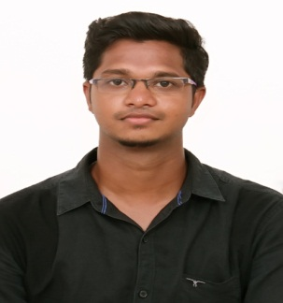

**NAME : ADHITHIYAN.P.G**

**DEPARTMENT : B.Tech [CIVIL ENGINEER**

**-------------------------------------------------------------------------------------------------------------------------**

**CAREER OBJECTIVE:**

Seeking a fulfilling position in an esteemed organization that offers growth opportunities and allows me to utilize my personal ability and academic skills for the upliftment of the organization.

**EDUCATIONAL QUALIFICATION:**

|  |  |  |  |
| --- | --- | --- | --- |
| **COURSE** | **INSTITUTION** | **YEAR OF** | **PERCENTAGE/CGPA** |
|  | **UNIVRSITY/BOARD** | **PASSING** |  |
|  |  |  |  |
| **B.Tech(CIVIL)** | PRIST DEEMED TO BE  UNIVERSITY | 2019 | 7.2 |
|  |  |  |  |
|  |  |  |  |
| **12TH** | BHARATHIDASAN | 2015 | 65 |
|  | MAT.HR.SEC.SCHOOL |  |  |
|  |  |  |  |
| **10TH** | VETRI VIKAAS  B.HR.SEC.SCHOOL | 2013 | 70 |
|  |  |  |  |

**SKILL SET:**

* AutoCAD, STADD.pro, REVIT, 3Ds max.

**ACHIEVEMENTS:**

* Actively participated in various sports activities for inter school.
* I have done compeering in inter college conferences and symposiums.

**PERSONAL MEMORANDUM:**

* NAME **:** Adhithiyan.P.G
* DATE OF BIRTH **:** 06-09-1997
* AGE **:**  22
* GENDER **:** male
* FATHER NAME **:** Prabakaran D
* FATHER OCCUPATION **:** Agricultural Officer [AAO]
* NATIONALITY **:** Indian
* LANGUAGES KNOWN **:** English, Tamil
* HOBBIES **:** Hearing music, Reading books, watching reality shows

**INTERPERSONAL SKILLS:**

* Confident and determined.
* Hard work and commitment towards work.

**DECLARATION:**

I here promise that information provided above us true to that best of my knowledge and believed.

**[ADHITHIYAN P G]**