CURRICULUM VITAE
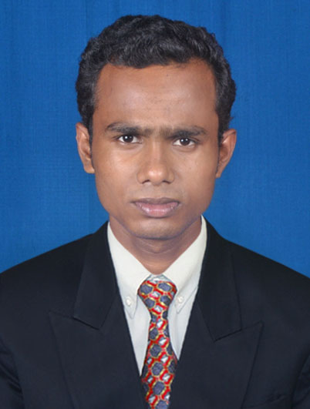
ASHITANSHU MAJHI

C/o :- Biswanath Majhi
At :- Naranpur
Po :- Fatepur
Dist :- Balesore
Pin :- 756048
Mobile – 9438084665, 9778866664
E-mail - amajhi16@gmail.com

CAREER OBJECTIVE:

To utilize my skills, knowledge and understanding on different social issues from real perspectives and uses of my experience effectively as a development professional in order to facilitate and accelerate process of organisational development.

SKILLS:

- Hard working person.
- Self confidence.
- Responsibility.
- Honesty.
- Friendship.

STRENGTHS:

- Punctuality, Capability, Difficult situation handling.
- Positive thinking, Believe in teamwork.
- An ever-learning attitude.
- More working Efficiency
Educational Qualification:
Examination | Name of the Institution | University | Year of Passing | Division
Matriculation | Fatepur High School, Fatepur | BSE , Orissa | 2006 | 2nd
+2 Com | Khaira College, Khaira | CHSE, Orissa | 2008 | 3rd
+3 Com | Bhadrak Autonomous College, Bhadrak | F.M. University | 2011 | 2nd
M.B.A | Krupajala Management Study | BPUT | 2013 | 6.31  CGPA

COMPUTER PROFICIENCY

- Post Graduate Diploma in Computer Application
- Tally

WORK EXPERIENCE

One Year work experience in MANAPPURAM FINANCE LTD. As a Jr. Asst. at Branch Balangir, Odisha

PERSONAL PROFILE:

Name : - Ashitanshu Majhi
Father’s Name : - Mr. Biswanath Majhi
Date of Birth : - 16th April 1991
Religion : - Hindu

Nationality : - Indian
Gender : - Male
Marital Status : - Unmarried
Language Known : - English, Hindi & Oriya.

DECLARATION

I hereby declare that all statements made herein are to the best of my knowledge and belief. In case any of the particulars furnished by me are found to be false at stage my application/candidate is liable to be summarily rejected.

Place: Bhubaneswar
Date: Signature

