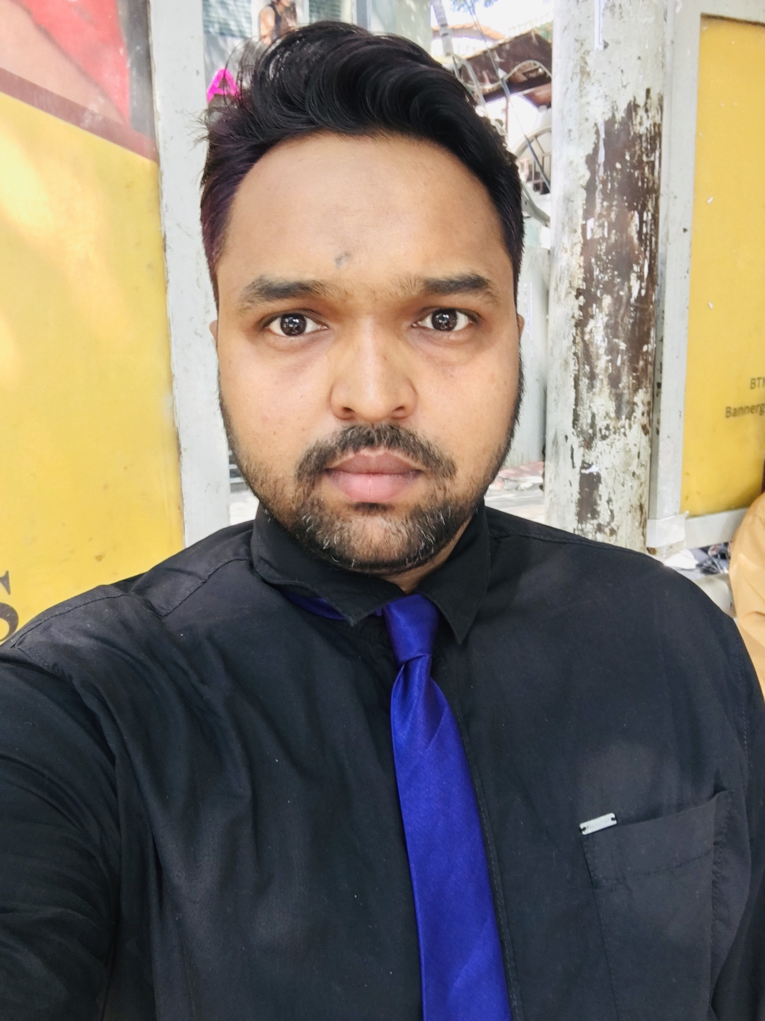**SHANEVALI MADABHAVI**

**DAE, BE-Mechanical**

**ICP-Service Level-I (ISHRAE)**

Contact-+91 8073663517

E-mail:Shan.madabhavi@gmail.com

**Operations Manager HVAC/R**

Manage residential, commercial and industrial HVAC/R needs, troubleshooting actions, Test and inspect systems to isolate faults and implement repair plans. Effectively align systems to meet manufacturer specifications and maximize performance. Execution of the tasks with the help of technical teams.

* **OBJECTIVES**
* Plan, assign, inspect and supervise maintenance, repair activities.
* Scheduling work plans to teams and motivating teams for successful execution of plans
* Handling clients requests and following up ASAP
* Assign and distribute work orders and work requests
* Maintain records and files, prepare required records..
* Attending and participating in meetings regarding work to be done
* Inspect contracted work as needed.
* Coordinate with other departments as needed.
* Ordering required materials and maintaining stock
* Provide technical assistance to Technicians when requested.
* Perform related work as required.
* **Qualification:**

*BACHELORE IN ENGINEERING (Mechanical) in 2013*

*Result-Second Class*

*DIPLOMA IN ENGINEERING (Mechanical) in 2007*

*Result-First Class*

* 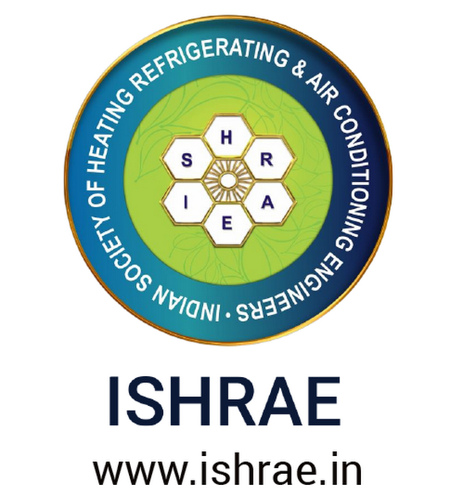***ICP AC SERVICE LEVEL-01 Certified by IIE, ISHRAE Bangalore chapter***

***Course content-***

The course covers Customer Service-soft skills, theory subjects covering ac systems refrigeration cycle, psychometrics, refrigeration components and controls, oils, refrigerants, good installation practices , trouble shooting. AC Plant Maintenance, Pressure testing, leak detection, vacuuming and practical demonstration.

* **Work experience:**
* **Operations Manager at *UFS-Maintenance & Solutions***

**  *Company-Jeddah, Kingdom of Saudi Arabia***

*Feb – 2020 to Till date*

*[Working remotely]*

Operate technical teams and assign them their daily schedules, following up their activity through Google live location maps and receiving their work updates. Handling client’s requests and assigning the suitable technician for the required complaints. Supporting and motivating teams to balance the work flow and smooth operations of maintenance activities, Attending MOMs and Monthly meetings timprove activities and liquidating the targets set by Top level management.

* **Service Engineer[HVAC/R]  *at Magnacool engineers***

*** Bang lore, Karnataka***

*Nov – 2018 to Jan-2020*

Maintain and perform repair on all refrigeration equipments and

perform troubleshoot on all HVAC equipments.

Manage all data centre applications and operate various Chillers and

HVAC systems and maintenance activities for various technicians.

Assist to plant instrument and perform troubleshoot on equipments

and ensure compliance to all EPA regulations. Monitor all resources and

ensure optimal utilization for same and achieve all customer objectives

and provide support to all equipments and perform calculations and

implement various plans for HVAC/R. Evaluate all approval systems for new and revised maintenance

jobs and monitor all work instructions and maintain all deliverables for projects.

* **Refrigeration engineer at *Al Rai foods industry***

***AL Ahasa, Saudi Arabia***

*Apr – 2018 to OCT-2018*

To work in operations and maintenance department my job responsibility

is to monitor all the refrigeration and air conditioning equipments. And

planning preventive maintenance plans and execute with technicians

Material and man power handling are the regular duties and supporting

team in troubleshooting the major break downs. Overhauling of semi

hermitic compressors of Copeland and Bitzer, Replacing of compressors

and brazing in outdoor units of Air-conditioning systems. Checking

operating parameters in SKIDS and adjust according to variation in set points.

***Task handled-***

* *Ammonia charging and draining*
* *Oil charging and draining*
* *Leak checking*
* *Compressor and capacitor replacing in AC outdoor*
* *Installing new AC and troubleshooting*
* *Replacing fans in -18 deg temp cold rooms*
* *Flashing of Evaporators*
* *De scaling of evaporative condensers*
* *Replacing of filters and dryers and electrical parts*
* *Replacing of Contactors and circuit breakers and solenoid valves*
* **Refrigeration and air-conditioning engineer at *Astra farms***

** *Tabuk, Saudi Arabia***

*OCT – 2016 to OCT-2017*

To develop work plans and supervise maintenance crews, repair and maintenance activities. Responsible for ensuring all refrigeration and air conditioning equipment required for the execution of activities is in good condition and performing optimally and helping management in selection of equipments and finalizing the quotations for projects , material ordering and manpower handling, Overall working for the self professional improvement and growth organization.

* Scheduling Daily, Weekly and Monthly preventive maintenance for water Chillers of primary refrigerant Brine and secondary refrigerant ammonia
* Scheduling Daily, Weekly and Monthly preventive maintenance for R & AC equipments
* Operation and maintenance Screw compressor of **Kobelco** make with the project maker **FRIGOTECHINICA SPA-ITALY**
* Knowledge on operation of **SCADA**
* Operation and maintenance of Vegetable and fruit stores of 0 to 5 Deg C temp
* Operation and maintenance of Pre-coolers of 35 to 20 & 20 to 0 Deg C temp
* Operation and maintenance of humidifiers to maintain RH 85 % and above
* Maintenance of Evaporative condensers of **EVAPCO** make water cool condensers
* Chemical dosing for water to avoid corrosion and algae formation inside condensers
* Operation and maintenance of centralized air conditioning system for Vegetables and Fruits packing area
* **Mechanical engineer- Refrigeration at *Allana cold storage ltd***

***Mumbai, India***

*Feb – 2014 to Sep-2016*

* Working on Preventive and Corrective maintenance of open type AMMONIA refrigeration plant.
* Annual and Half yearly maintenance of Reciprocating compressor as per manufacturer recommendation KPCL- Pune
* Operations and maintenance of all major equipment’s
* Estimation and costing of required materials for projects.
* Preparing BOQ for required projects and comparison sheet
* Installation of major Refrigeration equipment’s like Reciprocating Comp, Shell and tube Condenser, Cooling tower, Intercooler, Economizer, Liquid pump and Evaporator.
* Checking insulation and cladding for suction line and ensuring the work is as per required

**Worked on bellow projects:**

* Chiller room conversion to Blast freezer[21 MT capacity]
* Modification in cold store from blower type to axial flow fans.
* Ventilation system for PLATE FREEZER area.
* Conversion of blast freezer to chiller room for Sheep carcass chilling.
* Construction Blast freezer of 10 MT capacity

**Other activities:**

* *Attended INTERANTIONAL SEMINIOR ON INDUSTRIAL*

*REFRIGRATION SYSTEMS & AMMONIA SAFETY*

*ORGINISED BY*

*“ALL INDIA AMMONIA REFRIGERATION”*

*31st January 2015*

* *Attended ACREX-2016 IN BCEC ,MUMBAI*
* *Attended FIRE FIGHTING training organized by CEASE FIRE*
* *Attended AMMONIA SAFETY training organized by AAR*
* **Trainee engineer at *BOSCH Chassis systems Ind pvt ltd***

***Puna, India***

 *[Jun-2010 to Jun-2011]*

Troubleshoot, repair, inspect and maintain HVAC systems. Maintain the operator work station

Develop and implement preventive maintenance programs and supervise contractors within the district. Supervise contractors, along with commissioning jobs to assure completion of district investments. Perform maintenance and service repairs on pumps, safety valves etc.

Monitor and test water conditions in chilled water systems using chemical treatment and glycol

* **Achivements:**
* Received national award in The Bharat scouts & Guides “**RASHTRAPATIPURASKAR**” by Indian President Dr APJ Abdul Kalama
* Received state level award in The Bharat scouts & Guides “**RAJYAPURASKAR**” by KARNATAKA STATE GOVERNER
* Played basketball ZONAL VTU tournaments two times and winner for the academic year.
* **Personal details:**

Date of Birth : 09 JULY 1986

Sex : Male

Marital status : Married

Nationality : India

Passport no : **Z3846583**

Hobbies : Cooking, Playing basketball, chess and reading international journals.

Languages : Arabic, English, Hindi, Kannada and Marathi

Permanent

Address : C/O A.H.MADABHAVI

Indi road Rajput galli

Near APMC main gate

Vijayapura, Karnataka-586101

***Declaration:***

*I hereby declare that the information furnished above is true to the best of my Knowledge.*

Date:  **REGARDS**

Place: SHAN MADABHAVI