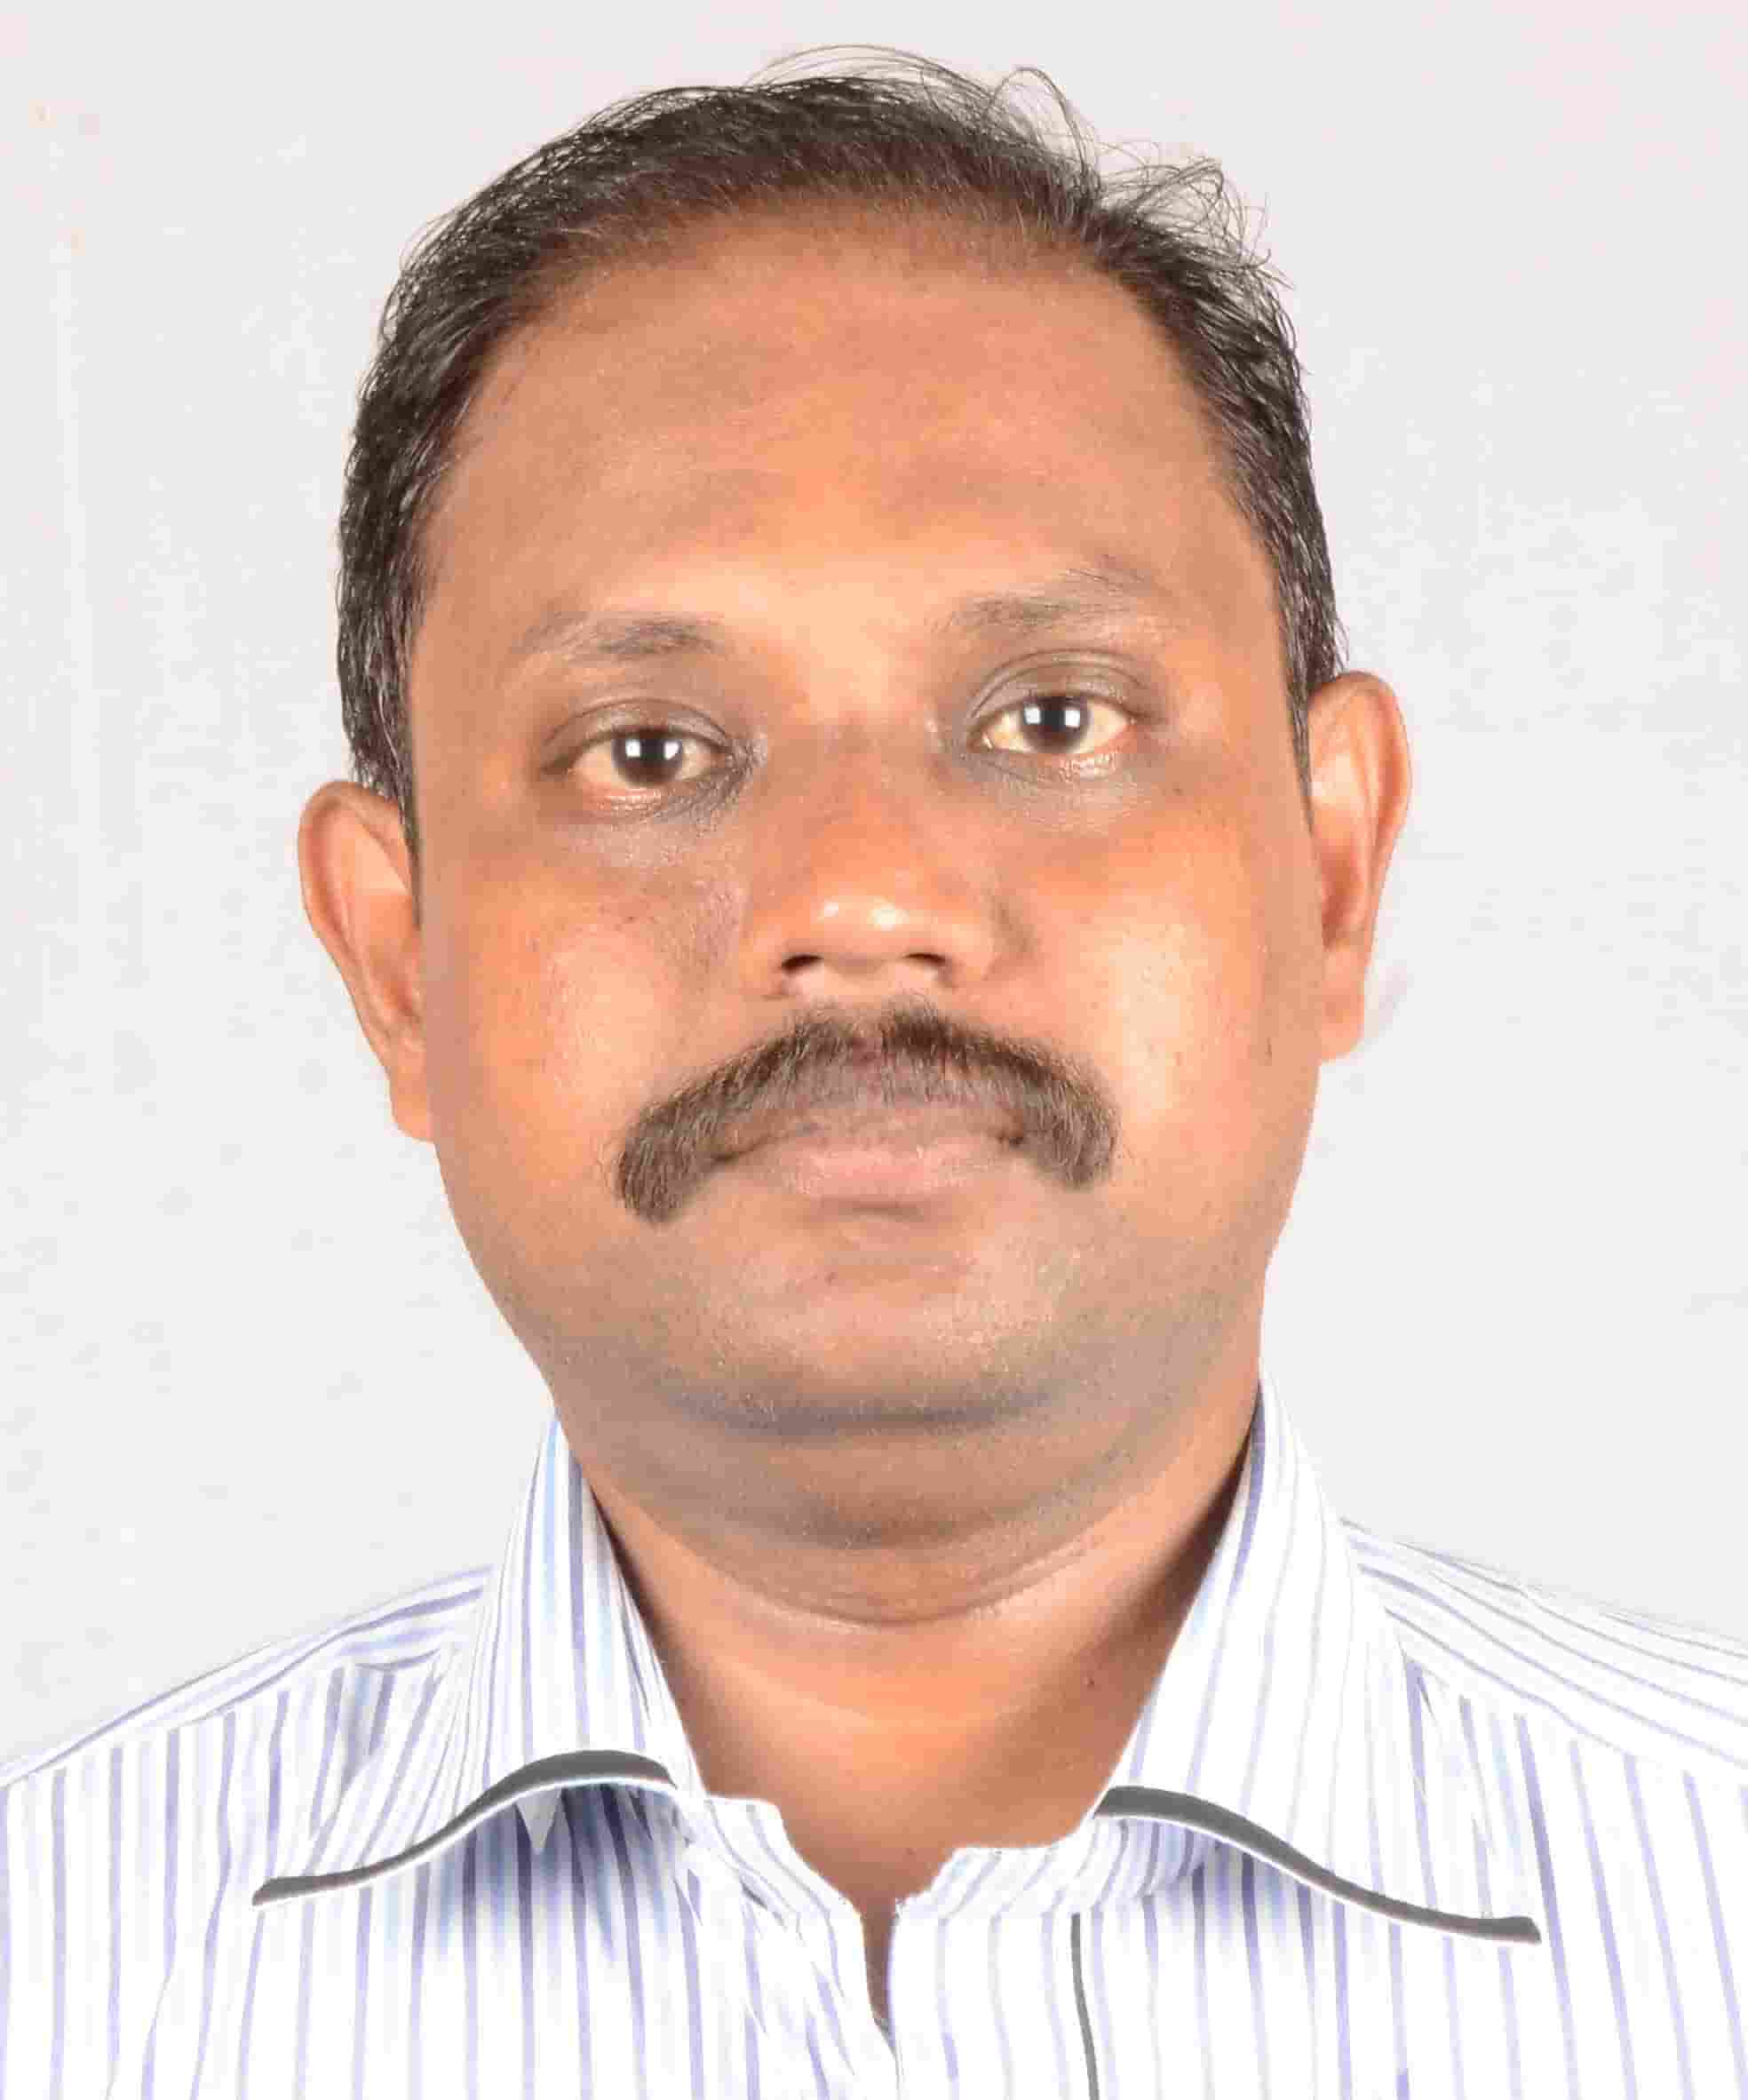
R.Jagadish Pandian
Mobile : +91 9842160832
Email : jpdit78@gmail.com

Seeking as System Engineer/System Admin/suitable post

SUMMARY

- 5 years of Experience in Subbalakshmi Lakshmipathy College of Science as System Admin
- 8 years of Experience in Delta info Tech as system Faculty cum Service Engineer
- 2 years of Experience in Micro channel as Desktop Service Engineer.
- 5 Years of Experience in TMC Computer education Center as Faculty.

WORK EXPERIENCE

- Working as Technical coordinator in Subbalakshmi Lakshmipathy college from Apr2016-Till Now
- Working as Faculty cum System Admin in Delta info Tech Madurai from Jan ‘07 to Mar2016.
- Worked as System service Engineer in Micro channel Madurai from Jun ‘05 to Dec '06
- Worked as Desktop Service Engineer in TMC Computer Education Madurai from Jun ‘00 to May '05

ACADEMIC QUALIFICATIONS

Course | Institution | Board | Year Of Passing | Class | Percentage
ME(CS) | Anna University  (Madurai) | Anna University | May2014 | FIRST | 62%
B.E (CS) | PSNA College of Engg., Dindigal | Madurai Kamaraj  University | Nov 2000 | SECOND | 57%
H S C | Seventh-Day Adventist Higher Secondary School, Madurai. | State Board | March 1996 | FIRST | 65%
S S L C | Seventh-day Adventist Higher Secondary School, Madurai. | State Board | April 1994 | FIRST | 65%

SKILL SET

Operating System : Windows 3.1 / 95 / 98 / NT / 2000 / Me / XP / Vista / 7 / 8 / 8.1 / 10,
Red Hat Linux EL-7, Windows 2003 / 2008 / 2016 R2 Server, SLFERM
Languages : C, C++, VB.
Packages : Ms_office, Tally.
Scripting Language : HTML, Flash.
DBMS : Oracle, MS Access.
Multimedia : Photoshop, PageMaker, CorelDraw.
Additional Qualification: CCNA Certification, MCSA & RHCE Course Completed.

WORK DETAILS

Subbalakshmi Laksmipathy College of Science
Role:
- Installation and Maintenance of LAN/WAN
- Installation of all type Hardware , Printers and Scanner
- Firewall operations and Maintenance (Sophos and Cyberoam)
- Maintenance of more than 650 systems and their Network
- Installation of Server and Antivirus software
- Installation and Maintenance of OFC, CAT5e Cables
- Maintenance of Windows 2008 R2 Server and Red hat Linux EL 7 server
- CCTV Installation, Management and Troubleshooting
- Video Conference Management and Trouble shooting
- Bio-metric and Door Lock device Handling and Maintenance
- Maintenance of Nautical and Driving Simulators

DELTA INFO TECH

Role:
- Teaching all types of application Software and Hardware Courses
- Installation of Operating systems and software
- Error Rectification and Updating of Software
- Hardware and Networking Error Rectification.
- Lab Maintenance.

.
TMC COMPUTER EDUCATION CENTER

Role:
- Class taken for C,C++,Ms-office, Tally, DTP,
- Assembling PC’s AT/ATX.
- Formatting and Partitioning the Hard disk drive.
- Installation and updating of Desktop OS, Networking OS and other software.
- Installing and configuring driver software.
- Troubleshooting hardware related problems.
- Managing system devices and network services.
- Sharing of Printers in network

MICROCHANNEL

- Installation of network card drivers and configuring the network.
- Cable Crimping and implementing an LAN.
- Installation of Desktop and Network Operating systems
- Administration and Configured of Microsoft Windows2000 Server, Professional.
- Sharing of Drives and Folders in network and mapping of drives and folder in the clients.
- Creation and Configured of Users and Groups.
- Performing backups and restoration
- Configured and Operated Cisco 2500 series router and catalyst 1900 series switches.
- Configured Routing Protocols RIP, IGRP, OSPF

Personnel details

Date of Birth: | 23.12.1978 | Address: | 141, Ansari nagar, 7th st, Ma-palayam, Madurai.
Gender: | Male | Email: | jpdit78@gmail.com
Nationality: | INDIAN | Contact No: | +91- 9842160832

Description

I, do hereby confirm that the information given above is true to the best of my knowledge.

Yours Sincerely

(R. JAGADISH PANDIAN)

