## CURRICULUM VITAE

**Divya.V**

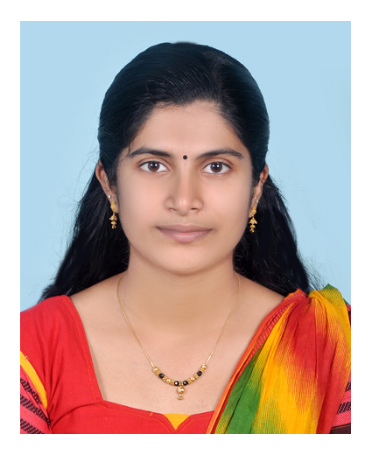

Ampady

Arkannoor(P.O),Ayur

Kollam (Dt)

Pin: 691533

Kerala

Email:divyavenugopal76@gmail.com

Mob No- 7994251058

**Carrier objective**

To pursue a challenging career in your esteemed organization and to utilize my knowledge of the subject and practical skills to the best possible extent in research and development and to grow professionally with your organization.

**Scholastic**

* 2017 : **Doctor of Pharmacy (Pharm .D)** with **69.2%** marks from Grace College of

Pharmacy,Palakkad (Kerala University of Health Sciences, Trissur).

* 2011 : **Higher secondary examination** (+2) in science with 86.6% from

Vivekananda Higher Secondary School, Kollam **(Board of Higher Secondary**

**Examination. Govt. of Kerala).**

* 2009 : **SSLC** (10th) with 94.6% marks from VHSE

Arkannoor, Kollam(**State Syllabus).**

**Training experience (Internship period)**

* Working as Pharm.D Intern from August 2016 to May 2017 in 4 departments of Karuna Medical College Hospital (350 bedded) rendering clinical pharmacy services and duties independently.
* Working as Pharm.D Intern from June 2017 to August 2017 at Travancore medical college and hospital (850 bedded) rendering clinical pharmacy services and duties independently.

**Work Experience**

* **Worked as Pharma executive in life pharmacy at Dubai on 02/10/2018 to 03/10/2020.**

**Dissertation**

* The profile of risk factors,common post stroke complications and functional outcome among first ever stroke patients in a tertiary care teaching hospital at palakkad - A prospective study.

**Clerkship (2015-16)**

10 months of clerkship at Karuna medical college Hospital, Palakkad undergoing practical training in wards to provide hospital and clinical pharmacy services in the following departments:

* **Department of General Surgery**
* **Department of Pediatrics**
* **Department of General medicine**
* **Department of Orthopedic**

**Areas of interest**

* Clinical pharmacy
* Teaching
* Clinical Research
* Pharmacovigilance
* Pharmaceutical care services such as identifying, analyzing and managing Drug-Drug interactions and other Drug related problems, Drug information, patient counselling with emphasis on improvement and quality of patient care.
* Higher studies

**Strengths**

* Excellent communication skill
* Good Presentation skill
* Hard working & positive attitude
* Leadership and management skill
* Self-motivated/self learner

**Computer skills**

* Basic knowledge of MS Office, MS Word, MS PowerPoint and proficient in internet usage.

**Publications**

* Wilsons disease - A Case Report; accepted by inventi rapid:clinical research.
* Amyotrophic lateral sclerosis(ALS) – A Case Report; accepted by Indian journal of Pharmacy practice.
* Prescribing pattern of drugs used among first ever stroke patients in a tertiary care teaching hospital at Palakkad-A Prospective study; accepted by inventi rapid:pharmacy practice
* A prospective study on the functional outcome among first ever stroke patients; accepted by journal of hospital pharmacy.
* A prospective study on the profile of post stroke complications among first ever stroke patients in a tertiary care teaching hospital; accepted by inventi impact:pharmacy practice
* A prospective study on the profile of risk factors among first ever stroke patients in a tertiary care teaching hospital,Palakkad; accepted by world journal of pharmaceutical and medical research.
* Prospective observational study of Asthma and its management of A tertiary care teaching hospital; accepted by indo American journal of pharmaceutical research

**Seminars/workshop attended**

* Participated as a delegate on ICPCR-2012 “Expanding Horizons and Changing Dynamics in Pharmaceutical and Clinical Research held between 11th and 12th October 2012 at Grace College of Pharmacy, Palakkad.
* Delegate in International seminar (IACP) on “Advancing pharmacy practice in India: The Next Generation Pharmacist held at Bengaluru on 21st & 22nd February 2014.
* Delegate in one day seminar on “Emerging Trends and Challenges in Patient Focused Pharmacy Education” held on 3rd November 2012. Organized by college of pharmacy, Sri Ramakrishna Institute of paramedical sciences, Coimbatore.
* Delegate in international conference “Evolving role of clinical pharmacist multidisciplinary healthcare settings” held on 8th & 9th 2016 January at manipal university,manipal.
* Delegate in 66thIndia n pharmaceutical congress (IPC) on “roll of Indian regulators and pharma industry” held at hitex, Hyderabad from 23rd to 25t, January 2015.
* Delegate in one day seminar on “Continuing medical education therapeutic drug monitoring” held on 20th 2015 November at Karuna medical college( department of pharmacology).

**Co-curricular activities**

* Was an active member of naval ncc attended All India Nau sainik camp at Vishakapattanam.
* Won prizes in workexperience in state level and participated in dance programs.

**Language known:**

Malayalam, English, Tamil, Hindi.

**Personal information**

Date of Birth : 01/05/1993

Father Name : Venugopalapillai.P

Marital status : Single

Gender : Female

Nationality : Indian

Permanent Address : Ampady

Arkannoor(P.O),Ayur

Kollam (Dt)

Pin: 691533

Kerala

**Reference**

1. Associate Professor: Mr. Jobin kunjumon

Grace College of pharmacy

Palakkad

Kerala

Mobile no: 9447516995

E mail: [jobinkunjumon@yahoo.com](mailto:jobinkunjumon@yahoo.com)

1. Pharmacist cum Store manager: Mr. Shiras

Life Pharmacy

Dubai

UAE

Ph. 971 567107165

**Declaration**

I hereby declare that all the above furnished information is true and correct to the best of my knowledge and belief.

**(Divya.V)**

**Date: 19/11/2020**

**Place: Kollam**