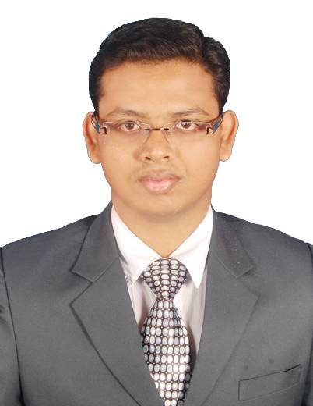**SRIKANTA JENA**

C/o. : Shankar Jena

Email ID : [jenasrikanta35@gmail.com](mailto:jenasrikanta35@gmail.com)

Mobile : +91-7377732738

OBJECTIVE:

Looking forward to work in an organisation where my skills are best utilised for the benefit of the organisation and improvement in the skills of self.

EDUCATIONAL QUALFICATION:

* Scored a CGPA of 8.48 in Bachelor of Technology in Mechanical Engineering at Institute of Technical Education & Research (ITER), Siksha ‘O’ Anusandhan University, Bhubaneswar.
* Scored 65.8 % marks in 12th at Buxi Jagabandhu English Medium School, Bhubaneswar under Central Board of Secondary Education.
* Scored 82 % marks in 10th at Buxi Jagabandhu English Medium School, Bhubaneswar under Central Board of Secondary Education.

SKILLS:

* Designing – Completed a course on Master in CADCAM & CAE (MCC) at CTTC, BBSR.
* Management – Lead project groups successfully at both college and training organisation.
* Team work – Successfully handled my project teams in all atmosphere.
* Innovation – I have a innovative mind and had changed the whole working atmosphere for a SMEs.

PROJECTS & WORKSHOPS ATTENDED:

|  |  |  |
| --- | --- | --- |
| **PROJECT NAME** | **:** | **ORGANISATION** |
| Multipurpose toolpost | : | Central Tool room and Training Centre, BBSR |
| Press-Milling workshop | : | Central Tool room and Training Centre, BBSR |
| Study of Air-Brake System in LHB Bogie | : | Easy Coast Railway, BBSR |
| Study of gear design & manufacturing | : | HAL, Koraput |

HOBBIES & INTEREST:

* Playing chess
* Swimming
* Internet surfing

STRENGTHS:

* I am adaptable to changing environment and trends.
* I am confident of doing any kind work and try to be perfect.
* I am dedicated to my work.
* I am patient in completing the work.

PERSONNAL DETAILS:

* Father’s Name : Mr. Shankar Jena
* Mother’s name : Mrs. Geetarani Jena
* Date of Birth : 23rd February 1994
* Gender : Male
* Maritial status : Indian
* Language known : Odia, Hindi, English
* Address : House no. LB – 35, At/Po. Badagada BRIT Colony,

Bhubaneswar, Odisha, Pin – 751018

DECLARATION:

I hereby declare that the details furnished above are true and to the best of my knowledge.

DATE:

PLACE: SRIKANTA JENA