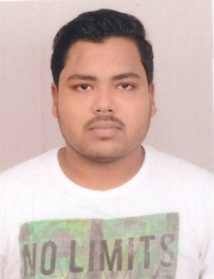

SUDIP HALDER

**Address:** Vill+post-Garhjoypur, Dist- Puruliya **Contact details:** 7001973827

**Email:**sudiphalder61@gmail.com

**Mobile:** 7864948416

**Career Objective**: As a fresher I wish to start in an atmosphere where my individual talent will be appreciated and I will be given the chance to acclimatize with the company’s goals and methodologies, through constant learning and performance.

**Key Skills:**

**IT:** C++, MYSQL, Microsoft office.

**Non- IT:** Well communication, Adaptabilities of cultures, Cricket (A-div, B-div), Mixing well with people, Driving Licence.

**Industrial experience:** None

**Educational Qualification:**

|  |  |  |  |
| --- | --- | --- | --- |
| Name of Examination | Year of passing | Board/ University | Percentage of marks |
| BCA | 2019 | MAKAUT | 6.97(DGPA) |
| Higher Secondary | 2016 | W.B.C.H.E. | 63.4% |
| Madhyamik | 2014 | W.B.S.E. | 48.8% |

Languages known: English, Hindi, Bengali

Other qualification (if any): Diploma in computer

**Awards and achievements:** Man of the series in A-division (cricket)

**Extra-curricular activities/ Interests:** Playing Cricket, Listening Music, cooking.

**Personal profile:**

**Father’s name**: Dipak kr.Halder

**DOB:** 1.12.1998

**Sex:** Male

**Signature:** 