# CURRICULUM VITAE

**SONALI NEGI**

H.NO. 46, YAMAHA VIHAR

SEC-49, NOIDA,

U.P-201301

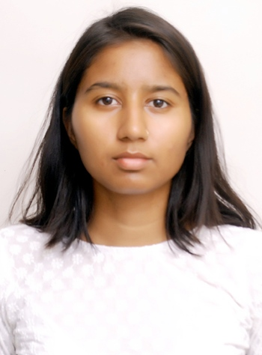

E-mail-id:sonalinegi4043@gmail.com

Contact no: 7042992105

# 

# OBJECTIVE:

* Looking for an opportunity to utilize my acquired skills and training to help the company and my future peers grow. I want my efforts to make a considerable difference to the company and help in their consequent success

# EDUCATIONAL QUALIFICATIONS

|  |  |  |  |  |
| --- | --- | --- | --- | --- |
| **Class/Degree** | **Passing**  **year** | **University/Board** | **College/School** | **Aggregate**  **(%)** |
| X | 2012 | CBSE | Rakha Anusandhan  Vidyalaya | 89.3 |
| XII | 2014 | CBSE | Kendriye Vidyalaya  OLF | 79.60 |
| B.Sc (Hons.)  Chemistry | 2017 | Amity University,  Noida | Amity Institute  of applied science | 72.4 |
| M.Sc(Applied Chemistry) | 2019 | Amity University, Noida | Amity Institute  of applied science | 73.9 |

**WORK EXPERIENCE:**

* Self Employed as PRIVATE TUTOR( November 2019- Present)
  + Responsibilities
    - Monitoring and assessment of student performance
    - Communicate with parents and teachers to update them on students' progress
    - Collaborate with students in order to create and administer practice exams, mirroring.
* Worked as SUBJECT MATTER EXPERT at ACADECRAFT PVT. LTD. (July 2019- October 2019)
  + Responsibilities
    - Developed study material, created and reviewed questions with detailed solutions.
    - Analyzed and interpreted the pattern and difficulty level of JEE, NEET, NET level exams.

# RESEARCH AND PROJECT EXPERIENCE:

* Dissertation (major project) on the topic "Modified 2d Nanocomposites for Effective Photodegradation for Removal of Methylene Blue Dye and Chromium Ion". (Jan 2019- May 2019)
* Internship at DIPAS (Defence Institute of Physiology and Allied Sciences), DRDO lab on the topic "phytochemical assessment of extracts obtained from medicinal mushrooms". (May 2018- June 2018)
* Three non-teaching credit courses during graduation were performed titled “Surface adsorption”, “Synthetic food colors” and “Solar cells using Nanoparticles”. (2014-2017)

# INSTRUMENTATION KNOWLEDGE AND OTHER SKILLS:

* Knowledge of various instruments involved in the chemical field such as HPLC, spectrophotometer, centrifuge and autoclave.
* Good knowledge of computers and various applications (MS word, chemdraw, Mathtype).

# EXTRA CO-CURRICULAR:

* Involved in various poster making competitions held at Amity University and achieved second and third rank in two of them.
* Participated as a team member in the National Children Science Congress during school time at national level.
* Volunteered in organizing the NATIONAL STUDENT CONCLAVE during 18-19th January 2018 at Amity University Uttar Pradesh, Noida.
* Active participation in badminton at school level.
* Active participation in chemical rangoli at college level.
* Active participation in writing competition at college level.

# PERSONAL TRAITS:

* Enthusiastic, Hard working and self motivated
* Good communication skills
* Adaptable and believe in continual learning

# PERSONAL DETAILS:

* Date of birth 15th August 1995
* Father's name Late Ravindra Singh Negi
* Gender Female
* Nationality Indian
* Marital status: Unmarried
* Languages known English, Hindi and Japanese(elementary level)

# DECLARATION:

* I hereby declare that above mentioned information is correct to the best of my knowledge and bear the responsibility for the correctness of the above mentioned particulars.

**Date: 12-10-20**

**Place**: Noida

(SONALI NEGI)