**MUHAMMED THANZEEM**

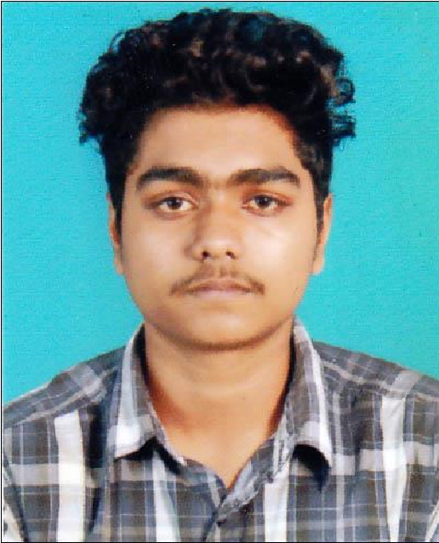

# Contact

**Objective**

Looking for a suitable position in your organization,where I will

perform my ability and worthness as per my qualification and

experience

**Skill Highlights**

•

Strong decision maker

•

Complex problem solver

**Personal Qualities**

•

Hard working and Confident

•

Loyal towards work and duties

•

Good Communication Skills

•

Self Motivated

**Personal Details**

•

**Date of Birth**

**:**

**02.10.1999**

•

**Marital status**

**:**

**Un Married**

•

**Nationality**

**:**

**Indian**

•

**Father’s Name**

**:**

**Babu**

•

**Religion**

**:**

**Islam**

**Education**

•

B.com

•

Plus Two

•

SSLC

**Declaration**

I hereby declare that all the details mentioned above are in

accordance with the truth and fact as per my knowledge and I

hold the responsibility for the correctness of the above

mentioned particulars.

Place :

**MUHAMMED THANZEE**

**M**

Date :

**Address:**

Chemmukathu House Thondankulangara Avalookunnu P O Alappuzha

**Phone:**

## 8089864206

**Email:**

mohammedthanzeemb@gmail.co m

# Languages

## English Malayalam Arabic