N.S.Suresh

TC 36/1540(11), H1,
Sreepadmam Residency
Sreevaraham,
Trivandrum-695009.
Kerala
Phone: +91 9447554139
Email: nssuresh@gmail.com

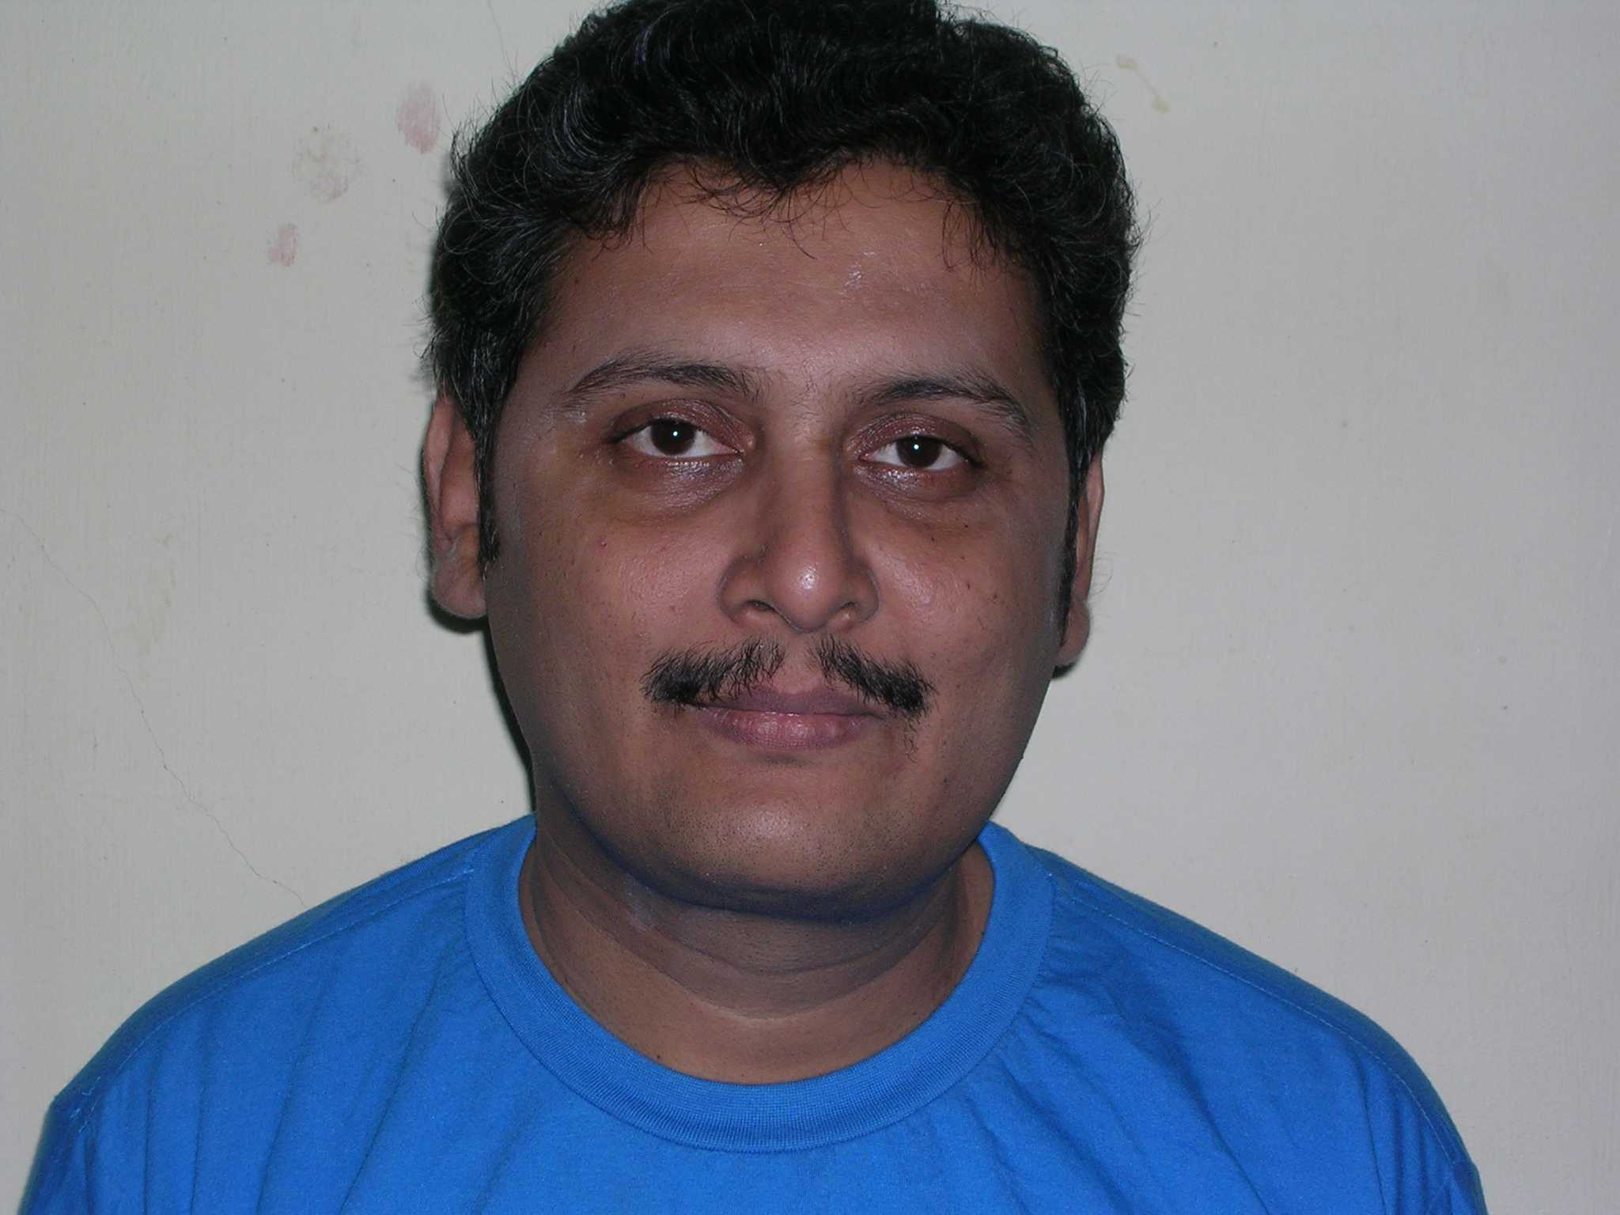

Objective

Looking for career opportunity. I want to contribute and learn and grow with the organization. I would like to interact with people and would be able to work along in teams of different sizes. I had worked in teams of about 20 people and interacted with all of them.

I have worked in three different industries namely civil engineering, computer education and medical transcription. I am a quick learner and adapts to any role that is given to me.

Education

Completed MBA in HR from ICFAI University, Tripura in January 2014 with 65%.

Completed Honors Diploma in Software Management APTECH, Trivandrum 72%.

Completed Diploma in Civil Engineering from Tamilnad Polytechnic, Madurai 1990 76%.

Completed SSLC from T.V.S. Higher secondary School, Madurai. 1987, 86%.

Special Certification:

I had obtained the Brain Bench Certification in MS-Excel Fundamentals and navigation in the year 2000.

Professional Experience

I had worked in computer training field for 6 years. I had worked with Datapro InfoWorld, SSI Computer Education and NIIT Limited.

I had worked as Technical Coordinator for SSI Computer Education arranging the running of the center along with various faculties and front office staff for two years.

I had worked in the medical transcription field for the past 8 years. Last worked company was Ansell MT.

I had worked in the civil engineering field for 5 years as site supervisor.

For the last 9 years I have been working with LIC of India as an advisor in Trivandrum branch.

Special Skills:

- I had conducted corporate training to employees of Vikram Sarabhai Space Center (VSSC), Trivandrum and Liquid Propulsion System Center (LPSC), Trivandrum consisting of Senior and Middle level Engineers as well as Administrative staff.

The batches consisted of 20 students in each batch. The staff were appreciative of my training and Mr. Madhavan Nair, the then Chairman of ISRO presented a memento to our faculty team.

Personal details

Date of Birth : 02-05-1972 Age : 47

Hobbies : Reading books, Newspapers.

Contact Nos : +91 9447554139

SUMMARY:

I would like career opportunity.

