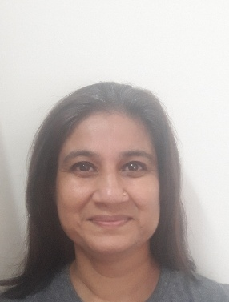

**MONICA GURBANI**

Email ID: [1343monica@gmail.com](mailto:1343monica@gmail.com)

Phone: 9769647247

DOB- 13/09/1975

Address – B Wing 603/ Poonam valley, next to don bosco school, Mira rd, Mumbai 401107

**Professional Experience**

Tech- Mahindra  *(5th August 2019 –30/04/2021)*

Process – Vodafone NBN

Role - Advisor

* Attending Inbound Calls
* Resolving queries on call

*Teleperformance (May 2018– August 2019)*

Process – TU

Role – Sr. CSE

* Attending Inbound Calls
* Resolving customer queries on call

Prettislim Health Clinic *(November2016 – September 2017)*

Role – Asst. Manager Sales

* Attending Calls
* Selling and Closing sales

Weddingz.in  *(October 2015 – October 2016)*

Role – CRM

* Keep contact with all the clients
* Generating leads
* Giving feedback to Sr. Management

YAxis Solutions*(October 2012 – May 2013)*

Role – Immigration consultant

* Counselling clients on immigration as per the eligibility criteria
* Generating leads
* Selling and Closing sales

Ayushakti Ayurved Health Center*(August 2009 – January 2011)*

Role – consultant

* Training staff on the job
* Interaction with foreign guest.

RSVK *(November 2006 – July 2009)*

* Training the executives
* Generating Enrolments

TVB Marketing India Pvt Ltd *(November 1997 – June 2001)*

* Resopnsible for hiring and training telemarketing executives
* Heading a team of 16 people, ensuring the daily targets are achieved.
* Preparing and handling weekly and monthly reports

**Education*:***

* *HSC – MMK College.* *(April 1993)*

Commerce

* BBVP – Pilani – Rajasthan

CBSE – 10TH Standard ( April -1991)

**Hobbies**:

**Running**: Take part in marathons and successfully complete them – the longest is a 22 k marathon I have completed.

**Listening to Music** – EDM and Trance

**Reading** – all sorts of books, no particular genre.