**MOHD ABID**

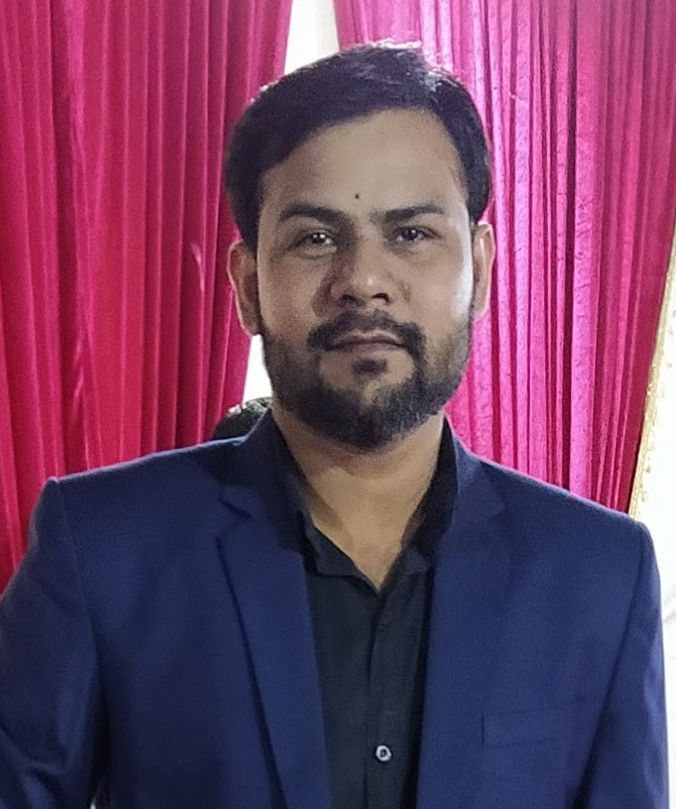

|  |  |
| --- | --- |
| Mob | : 9810257075 |
| Email | : [abidmohd099@gmail.com](mailto:abidmohd099@gmail.com) |
| Address | : H.No.2067, Street No.27b,Tughlakabad Ext., New Delhi-110019  . |

|  |
| --- |
| Career Objective: |

## To pursue a career with an esteem organization that can enhance & enrich my professional skills while getting a high level of satisfaction and recognition. Excel in every task assigned & set higher standards for me & organization work for.

|  |
| --- |
| Academic record: |

|  |  |  |  |
| --- | --- | --- | --- |
| **Professional**  **Qualifications** | **Examination** | **Year** | **Institution/Board** |
| CA-CPT | June 2009 | ICAI |
| CA-IPCC (Ist Group) | Nov 2011 | ICAI |
|  | CA-IPCC (2nd Group | Nov 2013 | ICAI |
|  | CA (Final- Group 1) | Nov 2018 | ICAI |

|  |  |  |  |
| --- | --- | --- | --- |
| **Academic**  **Qualifications** | B.com (Hons) | 2015 | Delhi University |
| 12th | 2009 | C.B.S.E. |
| 10th | 2007 | C.B.S.E. |

|  |
| --- |
| Work Experience: |

## Articleship Training under VRSK & Associates from July 2012 to July 2015.

* Worked as a taxation manager in Rastogi and Donald December 2015 to January 2018
* Currently working as a Senior Audit Manager with VRSK & Associates (CA Firm).

|  |
| --- |
| Accounts & Reporting: |

* Rich experience in entire gamut of accounting & finance operations entailing preparation &maintenance of statutory books of accounts and administering the finalization of year-endfinancial statements
* Track record of overseeing financial statements including trial balance, bank reconciliation reports, profit & loss account, age-wise accounts payables & receivables statements and balance sheets.
* Preparation of Financial Statements as per Schedule VI.
* Having wide experience in preparation and finalization of statutory audit reports
* Discussing of audit reports with senior management of respective companies and reading out reports in general meetings

|  |
| --- |
| **Taxation:** |

* Preparation of TDS Returns (Salary & Non-Salary) and Individual Income Tax Returns, Company, firm Income Tax Return
* Preparation and filing of income tax returns of various kind of assessee as per Indian Income tax laws
* Finalization of Assessment and scrutiny under income tax laws
* Preparation and filing of VAT returns as per Indian laws( Delhi state)
* Computation of VAT liabilities for different kind of tax payers
* Dealing in assessment of VAT cases selected for scrutiny
* Experience of Goods and Services Tax

|  |
| --- |
| **Concurrent Bank Audit:** |

* Punjab National Bank Limited
* Indian Bank Limited
* Oriental Bank of Commerce

|  |
| --- |
| **Internal Audit:** |

* National Building Construction Corporation(NBCC)
* National Thermal Power Corporation(NTPC)
* Momentum Techsys Private Limited

|  |
| --- |
| **Statutory Bank Audit:** |

* Punjab national Bank Limited
* Bank of Baroda
* Corporation bank Limited
* Indian Bank Limited
* Canada Bank Limited

|  |
| --- |
| **Statutory Company Audit:** |

During the period of articleship and later have done the statutory audit as per companies act of the many companies‚ small list of major clients handled are;

* Micro Precession Private Limited(Manufacturer of Maruti Auto parts and Home Appliances)
* Dream Factory Private Limited (Event Management Co.)
* Jinko Solar Private Limited (Solar Panel Industry)
* World Energy Council India
* Inventum Technologies Private Limited ( Software company)
* Vital Wires Consulting Private limited ( Sap Consultant)
* Blue Ray Technogies Private Limited( Traders of Electrical items)
* Rams Business Solution Private Limited( Recruiter)
* Shubhram Hospitals Private Limited (Medical Support Services)

|  |
| --- |
| **Tax Audit:** |

* Wide experience of preparations and finalization of tax audit reports
* Conducted Tax audit as per Indian Income tax laws

|  |
| --- |
| Other experience : |

* 35 Hours Orientation programme conducted by ICAI.
* 100 Hours ITT Programme conducted by ICAI.
* 15 days General Management and Communication Skill programme conducted by ICAI
* Leaded a team of around 4 to 6 persons at time for multipleprojects

|  |
| --- |
| Computer proficiency: |

* Familiar with accounting software –Tally ERP 9, SAP
* Microsoft Excel
* Microsoft Word
* Familiar with Taxation software – Spectrum (Income Tax, TDS)
* Familiar with Taxation utilities for filling Service tax, TDS and Delhi VAT Returns.

|  |
| --- |
| Personal dossier: |

|  |  |
| --- | --- |
| Hobbies | * : Listening music‚ |
| Date of Birth | : 10thMarch 1992 |
| Father’s Name | : Mohd. Rafique Ahmed |
| Language Known | : Hindi and English |
| Marital Status | : Single |