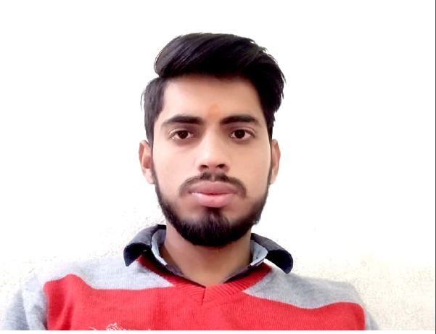

UTKARSH AGNIHOTRI
utkarshagnihotri1234@gmail.com
autkarsh870@gmail.com
+919044867679 / +919140252223

CAREER OBJECTIVE:-
To work in an organization where I can utilize and apply my knowledge, skills which would enable me as a fresh graduate to grow while fulfilling organizational growth.

EDUCATIONAL QUALIFICATION

COURSE | COLLEGE/SCHOOL | UNIVERSITY/BOARD | YEAR | PERCENTAGE
B.Tech(C.S) | M.P.E.C, Kanpur | AKTU | 2019 | 65%
Intermediate | R.R.D.S | U.P. BOARD | 2015 | 73.4%
High School | R.R.D.S | U.P. BOARD | 2013 | 80.0%

SKILL

- C Language
- OOPS
- Core JAVA
- SQL
- Data Structure
- Manual Testing
- Windows 8/10,
- Linux
- WAMP Server

PROJECTS
- PROJECT TITLE : Student ERP Management System.
Description-It is based on web development and it gives the college information like Courses, Admission form, Branch, Placement details, etc.
Tools and Technology:
- HTML ,CSS, Java script , Php
- Advantages :
Better Performance by Students.
Managing Timetable.
Complete Tracking of the Students.
Easy access to all data.

- PROJECT TITLE: Hotel Management System

Description-It is based on web development and it gives the Hotel information.

Tools and Technology:

HTML ,CSS, Java, Sql.
- Advantages :
Must automate hotel operation.
Capture and analyze guest details.
Strong after-sales support.
Multiple features.
Certificates
- C Language (BTPS Kanpur)
- Core java (Q Spider BTM Bangalore)
- Sql (Q Spider BTM Bangalore)
- Manual Testing (Q Spider BTM Bangalore)

ACHIEVEMENTS
- Participated in ROBBO WAR - Fest 2015 at M.P.E.C
- Attended Workshop on ETHICAL HACKING Conducted by KYRION TECHNOLOGIES Pvt. Ltd.
- Attended Training on C –Language at B.T.P.S Kanpur.

PERSONAL DETAILS

- Name :- Utkarsh Agnihotri
- Father’s Name :- Dileep Agnihotri
- Date of Birth :- 25/12/1998
- Language Known :- English, Hindi
- Current Address :- BTM Bangalore

DECLARATION

I hereby declare that all the above given information is true to the best of my knowledge.

Place: Bangalore
Date: / / UTKARSH AGNIHOTRI

