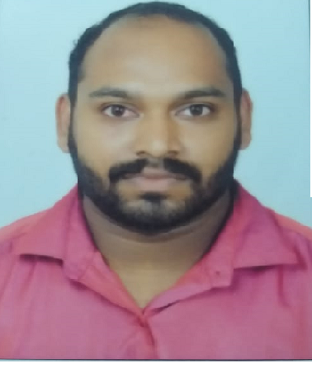
RESUME

Bibin Jacob John
Punnackal (H)
Chunkappara P.O
Pathanamthitta
Pin; 686547
bibinjacobjohn510@gmail.com
Contact no +91 8086639457

Objective:

To work in an environment that enriches my competencies and work towards achieving the goals of the organization. Seeking a challenging career position, that will compliment my educational and professional experience.

Project Experience:

Academic Profile:

Qualification | Institution | Board/University
BBA | St.Joseph’s Off Campus Centre Of Computer Science and Management Studies  Mallappally | MG university
Higher Secondary | CMS Higher Secondary School Mallappally | Higher Secondary Board, Kerala
S.S.L.C (X) | St.George High School Kottangal | Board of Public Examination, Kerala

TECHNICAL QUALIFICATION
Computer Knowledge-Tally ERP-9
EXPERIENCE
- 4 Year’s Experience in Tally ERP-9 in Accounts & Auditing department .

Personal Profile:

Name : Bibin Jacob John
Permanent Address : Punnackal (H)
Chunkappara P.O
Pathanamthitta
Pin ;686547

Date of Birth : 17-08-1994

Nationality : Indian

Marital Status : Single

Languages : English, Malayalam

Contact No : 8086639457
Email : bibinjacobjohn56@gmail.com

Declaration:

I hereby declare that the information furnished above is true to the best of my knowledge.

Bibin Jacob John

