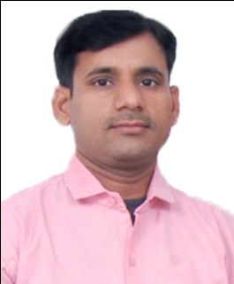**Resume**

**Jitendra Sahay**  **Cell** : +91 8090342377

9935967664

B-146, Barra-8,  **Email** : [sahay.gd@gmail.com](mailto:sahay.gd@gmail.com)

Kanpur.

**Objective :**

To obtain a position of Senior Graphic Designer in an esteemed organization, where I can work with new challenges, enthusiasm and goals to prove my qualification and experience in the good self of organization.

**Professional Qualifications:**

· HNC (Honors Diploma in Computer Information & System Management) From NIIT, Etawah. 1999 to 2000.

· Diploma in Graphic Design for Concept Academy art and Design – Kanpur .

**Computer Skills :**

· Coral Draw

· Adobe Photoshop

· Adobe Illustrator

· & Microsoft Office (Word, Excel, PowerPoint)

**Job Profile :**

* Creation of New Artworks.
* Design for Primary and Secondary Packaging.
* Print Media Ad Design.
* Designs for Branding – Wall Painting, Hoarding, Banner, Canopy etc.
* Designs for POP Material - Poster Sticker, Diary, Estimate pad, Calendar etc.
* Miscellaneous Designs – Book Composition etc.

**Key Skills:**

· Design from concept to completion for products.

· Visualization and creating concepts for print media ads.

· Free hand Hindi & English Typing.

· Creative imagination and team player attitude.

. I am work with TRP System Navision also.

**Work Experience : 14 Years**

· Graphic Designer at Mohani Tea Leaves (P) Ltd. Since- 2008 To Till

· Assistant Brand Executive Mohani Tea Leaves (P) Ltd. 2006 To 2008

· Office Executive At Mohani Tea Leaves (P) Ltd. 2004 To 2006

· Assistant Graphic Designer Sahu ji Printer 2002 To 2004

· DTP Operator Mayur Printing Press 2001 To 2002

**Education :**

· Graduate (B.A.) from C.S.J.M. University Kanpur 1999.

**Personal Detail :**

DOB : 02.01.1979

Qualification : Graduate

Father's Name : Late Vishun Dayal Srivastava

Language Known : Hindi and English

Marital Status : Married

**Declaration :** I hereby declare that above given detail correct as per my knowledge.

**Current Salary** : 2.76 LPA

**Date:**

**Place:** Kanpur **(Jitendra Sahay)**