

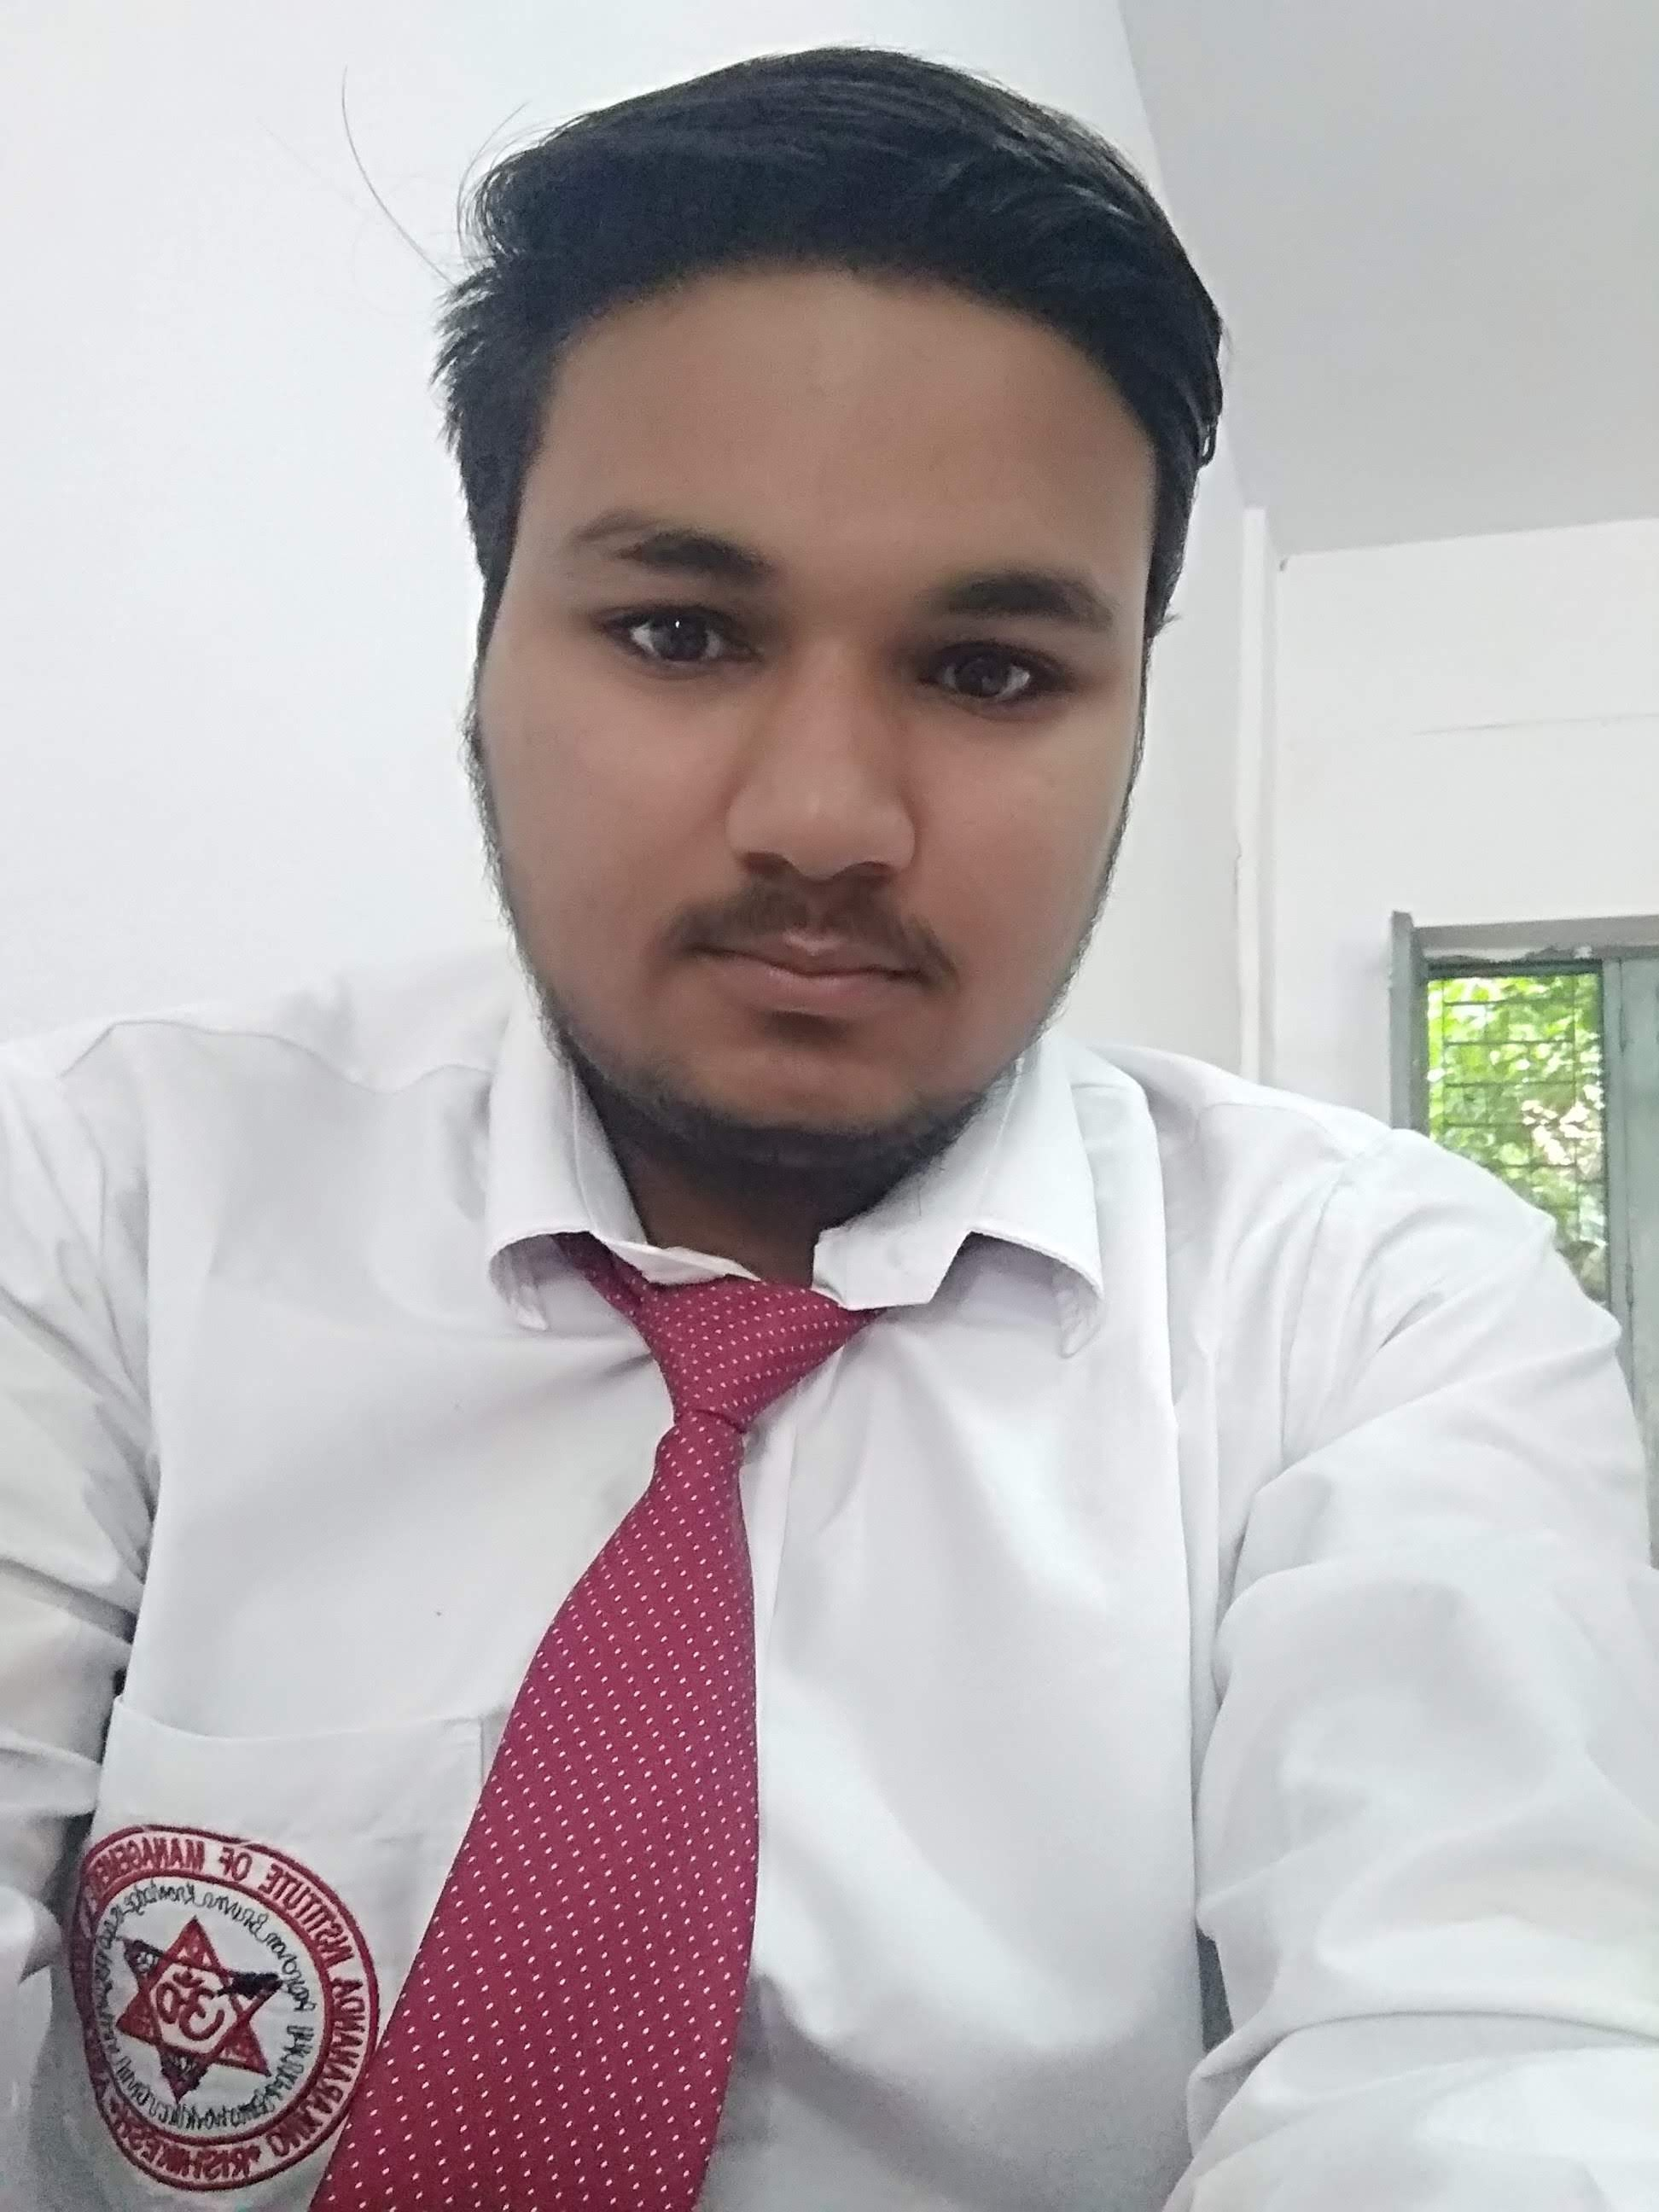

**Sanjay Ghimere**

Shiv chawk near KMT, laxman jhula, Rishikesh, 249201

Contact No. – (+91)8077747207

Email Id- [Sanjay.ghimere9@gmail.com](mailto:Snjay.ghimere9@gmail.com)



**Educational Qualifications**

|  |  |  |  |  |
| --- | --- | --- | --- | --- |
| **Education** | **Course** | **School/College/University** | **Passing Year** | **Percentage** |
| Graduation | **BCA** | Omkarananda Institute of Management and Technology | 2021 | 65% |
| Intermediate | **Science** | Sai Baba International Public School | 2017 | 50.8 |
| High School | **Matriculation** | Sai Baba International Public School | 2015 | 60.8 |

**Technical Skills**

* Python
* HTML, CSS, JavaScript

**Strength**

* Leadership
* Positive Attitude
* Good Listener

**Projects**

* Designed website for a Book Store.
* Designed website for Hotels and manage

**Interests**

* Traveling
* Volunteering