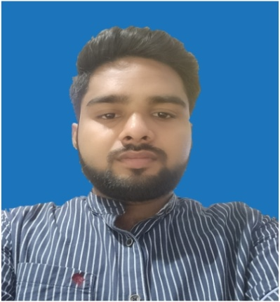

**2021**

**7.50 GAP (Last 4 Semester Avg. )**

**Aryan Kumar**

**INTERESTS**

**50.10%**

**Sree Ayyappa Public School**

**Hindustan Institute Of Technology & Science**

Bachelor Of Computer Applications

**HSC**

**2018**

**2015**

**SSC**

**8.6 CGPA**

**Anandalaya Public School**

**Programming Languages:** Java, .NET, PHP, C, C++

**Web designing Languages:** HTML

**aryankumar63.ak@gmail.com**

**ABOUT ME**

**CAREER OBJECTIVE**

**Date of Birth: March 15, 2000**

**Age: 20Gender: Male**

**Birth Place: Dumka**

To seek a position in a well established Organisation that offers room for professional growth, as this provides me ample opportunities to exhibit my skills and competencies in the chosen field.

**CONTACT**

**ACADEMIC BACKGROUND**

**SKILLS**

**EXPERTISE**

**Vill-Dighi, Dumka Jharkhand**

**08877159333**

**Wordpress**

**Adobe Creative Cloud**