[First Name]  [Surname] |  | 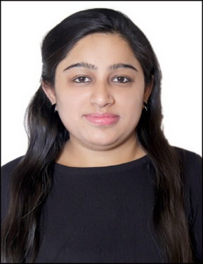

SUMMARY
- I have total 3 years and 9 months of Experience with Publicis Istrat and Digifish3 Pvt Ltd.
- Team player with strong analytical and leadership skills.
- I have also worked for some of the Outbound Voice process in Heroites and worked as a sales coordinator in Quantum Pvt Ltd Gurugram.
- Abilities in handling multiple activities with timely delivery and meeting the deadlines.
- Endowed with a passion for winning as evinced through demonstrated excellence in the academic & extracurricular areas.

Skill Highlights
 |  | Contact
[Your Address]
[City, ST ZIP Code]
 |  | [Your Phone]
 |  | [Your Email]
 |  | Your Website
- Project Management
- Strong Decision Maker
- Complex Problem Solver
- Innovative
- Service-Focused

Experience
Assistant Manager- Digital Marketing and BD
04/2015 to 09/2015
Digifish3 Pvt. Ltd, Gurgaon Haryana

This organization started its operations in 2015 with a small and
enthusiastic digital players who like to deliver best digital flavors to
their clients. I Pitched Ittude.me an ecommerce fashion store and
provided end to end 360 degree digital marketing support for
marketing its online presence and increased website footfall through
different digital marketing tools.

- Website management outlook based on the client requirement
and identify the current trend of the industry to meet the
industry qualities.
- Managing Blogs and social media platforms such as Facebook,
twitter, Instagram and Youtube.

- Updating Weekly funnel and assigning tasks to the team for end to end results.
- Maintaining the meeting agenda and work reports as discussed with the client.
- Provide content for Digifish3 social media pages, blogging, Meta tags, description for all the key accounts held by the company.
- Briefing the team all the client requirement about creative and website landing pages.
- Tracking and maintenance of reports social media pa
- ges and comparison between past and present performances and mapping the future plans.
- Updating Daily Task report at the end of the day and comparing the tasks with the defined targets.

