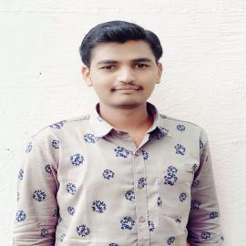**Swapnil Vilas Kathale**

# Mobile: 8308178262 / 9370047695

**Email:** [kathaleswapnil98@gmail.com](mailto:kathaleswapnil98@gmail.com) **Address:**

*At post Mithsagare, Tal:-Sinnar, Dist:-Nashik.*

To gain Experience and knowledge by working with dynamic, growth orientation, organization, one that encourage me to contribute usefully and offer me an opportunity to learn and advance my skill.

**Objective:**

**Job Experience**

Fresher -

**Education**

|  |  |  |  |
| --- | --- | --- | --- |
| **Degree/Course** | **Institution** | **Year of Passing** | **Percentage/CGPA** |
| M.Sc ( Electronic Sci) | Fergusson College Pune | 2021 | Pursuing |
| B.Sc (Electronic Sci) | K.R.T. Arts ,B.H. commerce & A.M. Science college,  Nashik. | 2019 | 77.6 |
| 12th (Sci) | L.V.H. College Panchavati, Nashik | 2016 | 56.3 |
| 10th | P.B. Kathale Madhyamik Vidyalaya Mithsagare. | 2014 | 81.2 |

**Project Details**

**Project Title:- ICU Patients Monitoring System Using GSM Technology.**

**Description:-**In this project we monitoring the condition of patients they situated in the ICU. We measure the heart rate (pulse rate), body temperature of the patient. If incase any changes happen in the patient body, Immediately message send to the doctor and patient relative using GSM module and immediately action take place.

**Duration**:-1 Year **Role**:-Project Builder

**Team Members**:-2

**Field of Interest**

Software development

* Embedded System

**Skills**

Programming languages:- C, Java, Python.

* PCB Design.

**Strengths**

Smart worker, Hard Worker, quick learner, good observer.

**Hobbies**

Playing cricket, Cycling, Trekking.

**Personal Details**

**Father's Name**:-Vilas Ananda Kathale

**Date of Birth**:- 9/9/1998

**Gender**:-Male

**Marital Status**:- Unmarried

**Nationality**:-Indian

**Languages Known**:- English Hindi Marathi

**Declaration**

# I hereby declare that the above mentioned details are true to the best of my knowledge.

# (SWAPNIL VILAS KATHALE)