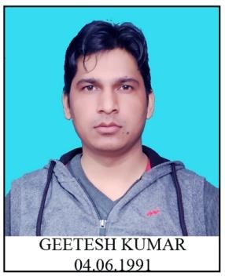CURRICULUM- VITAE

**GEETESH KUMAR**

# CAREER OBJECTIVE:

**G-71 EAST VINOD NAGAR EAST DELHI -110091 MOBILE NO-8800701712**

**Email –** [**geeteshkumar@gmail.com**](mailto:geeteshkumar@gmail.com)

Seeking a satisfying career where I can utilize the essential elements of my qualification, experience, personal skills,interest& direct them towards the success.

# EDUCATIONAL QUALIFICATION:

* **B.A (Hindi Hons)** from **Dr. BR. AMBEDKAR University** AGRA (Appearing)
* 12th Passed from **U.P. BOARD**
* 10th Passed from **U.P. BOARD**

# TECHINICAL QUALIFICATION:

* Basic Knowledge of Computer in Ms-Office & Social Media.

# WORKING EXPERIENCE

* Worked as a Daily wager in Directorate of Film Festival (DFF) from 3rd June to 31st may 2018
* Worked for 64th, 65th & 66th National Film Awards in DFF as a Coordinator for smooth functioning of Jury Screenings.
* PFMS, Coordinated with many callers for Online Entry – National Film Awards, maintaining office files end other important documents Etc.
* Worked with Indian Panorama 2018 in Delhi and Coordinated with the applicants for online submission of entries and Bharatkosh Payment.
* Worked with 45th, 46th, 47th, 48th & 49th International Film Festival of India, Coordinated with Preview committee Jury, Delegate Registration and maintaining of office files.
* Worked with 1st BRICS Film Festival in Delhi as a Jury Assistant

# POTENTIAL

* Flexibility & Empathic Learner,
* Hard Working with Positive Attitude

# PERSONAL INFORMATION

Father’s Name : Shri Bijendra Singh

Date of Birth : 4th Jun.1991

Gender : Male

Marital status : married

Religion : Hindu

Nationality : Indian

Languages Known : English, Hindi

# DECLARATION;

I hereby declare that all that above information is true to the best of my knowledge and belief.

Date : .03/05/2019

Place: Delhi **(GEETESH KUMAR)**