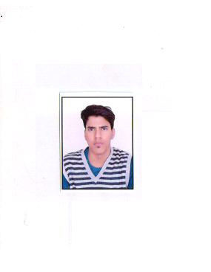

**RESUME**

NAME: Agrasen Kuldeep Singh

AGE: 24 year’s

GENDER: Male

DATE OF BIRTH: 6/6/1996

NATIONALITY: Indian.

LANGUAGES KNOWN: Hindi, English, and Gujarati.

**About Me**

My objective is to exploit my academic knowledge and zeal to excel in the field of business management for growth, development and benefit of organization as well as enhancement of personal knowledge and skills.

To remain in growth-stage of learning curve and thereby contribute continuously and positively to attain organization benefits.

EDUCATION QUALIFICATION:

|  |  |  |  |  |  |
| --- | --- | --- | --- | --- | --- |
| EXAM | YEAR | UNIVERSITY/BOARD | SUBJECT | % percentage/ CGPA | ATTEMPT |
| S.S.C. | 2012 | GUJARAT SECONDARY EDUCATION BOARD |  | 64.36 | FIRST |
| H.S.C. | 2014 | GUJARAT SECONDARY/HIGHER SECONDARY BOARD | COMMERCE | 66.27 | FIRST |
| BCOM. | 2017 | GUJARAT UNIVERCITY | ADVANCE ACCOUNTING & AUDITING | 54.37 | FIRST |

**CERTIFICATES:-**

**I, have also successfully completed the course in fundamental of digital marketing by Google.**

**I, have also done the course of brand management course by Indian Institute of management Bangalore.**

**I, have also done the certificate on facebook social media marketing by coursera.**

* **EXPERIENCES:-**
* 2.1year’s experiences in XSIS VALVES PVT.LTD.

As Marketing Executive in B2B.I have done Marketing for XSIS VALVES PVT.LTD. And help the company in expanding their business.

My work in this company is to promote the web site by using Google ad, creating and updating content for the website, help in making content for making YouTube video of the company , creating facebook page ,Updating facebook content daily, promoting facebook post of the company. doing mail marketing and promoting brand by registered the companies in various Expos.

**Computer Proficiency**

* MS office
* MS word,
* MS PowerPoint

**CO-CURRICULAR ACTIVITY**: Anchoring and Event management.

**HOBBIES** : Watching movies, Reading, Acting &Playing football.

**Contact Number** : 9427913559

**Email id** : [agrasensingh16@gmail.com](mailto:agrasensingh16@gmail.com),

**Declaration**

I, Agrasen Singh , hereby declare that the information contained herein is true and correct to the best of my knowledge and belief.



Agrasen Singh Ahmadabad, Gujarat.