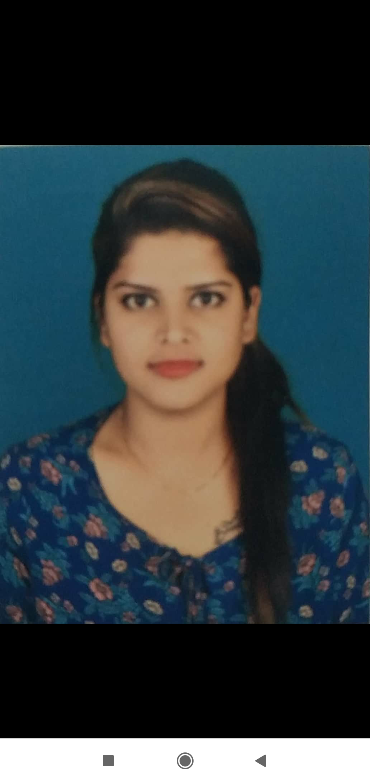
Rakshita Chourasiya (Rinki)

M: 91-7229906316
E: ritz28chourasiya@gmail.com

Professional Summary

I seek a challenging assignment in organization that will utilize my knowledge and experience. My aim is to contribute to the objective of the organization and to grow with it. Having an experience in the fields of competition, I can be sure of my commitments towards the Company, which will endeavor far most in achieving goals.
Employment History

August 2013 To December 2016

Credit Manager- Riddhi-Siddhi Credit Co-operative Society Ltd.
Job Responsibilities:
- Issuing personal loan (Self-help group funding range 20k-50k) & mortgage loan (50k  50 lac) , Agriculture land loan
- File processing of all types of loan (Collection of docs to final disbursement)
- Entry in software (Acute Easy Bank)
- Voucher making ( Loan )
- Verifying documents for all types of loan (Original docs seen and verified)
- All legal Issues in loan (Legal notice to customer for not paying instalment, With help of advocate you were monitoring NPA case also and follow up with collection team for final resolution)
- Handling Cash & Banking Transactions (RTGS, NEFT)
- Dealing with customer for appropriate loan advice.
- Making excel reports. (NPA list, All loan collection list, Handling a team of 7 members (collection / Calling/file processing)
- Loan disbursement Personal loan 5 lac / Mortgage 50 lac (MOM)
February-2017 to July-2017

Team Management at Escorts Ltd

- Management (PT- Dealership- 23 / Entire Sales process taken care in All Rajasthan)
- Software (E - SMS System Work)
- Leadership

HDFC LTD. (AS A DSA) September 2017 to December 2018
All Types Loan Provider Connected

HOTEL UDAI KOTHI
Hostess ( January 2019 to July 2019)

- entails welcoming and greeting guests
- Addressing the complains
- Cordinating with house keeping & all
- Sound decision making
- Collect Guest feedback during guest departure along with his likes and dislikes
- Handling guest complaints and concerns in an efficient and timely manner
- Telephonic base clients engaged

Education

Masters of Arts: Mohan Lal Sukhadia University in 2018
Bachelor of Arts: Mohan Lal Sukhadia University in 2017

Skills

- Diploma Course of Business Management
- Windows, internet, Email
- Complete knowledge of MS Office (Word, Excel, Power Point)
- Good guest interaction skills
- Good listening skills

Strength

- Positive attitude, hardworking and ability to work under pressure
- Ability to reach goals
- Leadership quality
- Hard working

Personal Information:

- Name: Rakshita Chourasiya (Rinki)
- DOB: 28th Feb 1993
- Address: 85/11 21st cross 7th main NS Paliya BTM 2nd stage Bangalore 560076
- Languages: Hindi, English
- Marital status: Single
- Father's Name: Satyanarayan Chourasiya
- Father's occupation: Pvt. Job
- Mother's Occupation: House Hold
- Siblings: one younger brother and 1 elder sister

