Curriculum Vitae
ARVIND KUMAR
R/O CTM COLONY Q. NO-E2-104
TEH. & DIST. KATHUA (J & K ) 184102 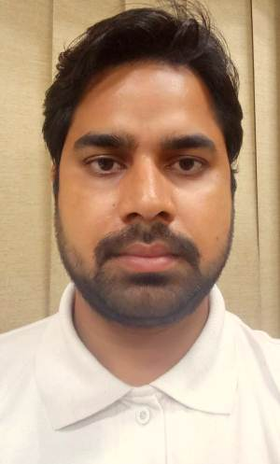
Mobile no - 8803184350,7780863435
e-mail :- arvindpandey@sutlejtextiles.com./arvindpandey.640@rediffmail.com

AIMS
- Seeking a position where I can make use of my Knowledge along with my work experience in sales.
- Opportunities to learn new things.
- Utilize my talents...

Work Experience
- Sales department since Dec 2016 in Sutlej Textile Industries unit CTM Kathua ( J & K ).
ROLE – JOB DESCRIPTION
Planning for dispatch & load and unloading material coordinate with god own
Keeper.
Monthly Insurance.
Billing (Domestic) & E-way bills.
Transporter freight invoice park document.
Coordination with marketing & Transporters.
- Data entry operator (DEO) in Jammu (2015-16).

Education
- Metric from J&K State board
- Intermediate from J&K State board
- Diploma in DCPA.
- Graduation in B.com from Agra University.

Computer knowledge
- Fundamental of the computer.
- MS Office, excel, Photoshop, PowerPoint.
- SAP Software.

Personality & Traits
Young, energetic, self-motivated, quick learner, good in maintaining inter-personals, hardworking, go-getter and self-starter, good co-ordination skills, ability to remain self-motivated in adverse circumstances, ambitious & responsible person.

Hobbies
- Passion for new technology, Net-surfing, Listening Music

Personal Details & permanent address.
Father name : Joginder nath pandey
Mother Name : Monika Devi.
DOB : 05-12-1992
Sex : Male
Marital Status : Married
Village/ PO : Beruarbari
Dist. : Ballia
State : Uttar Pradesh

Declaration

I hereby declare that all the information in the resume is correct to the best of my knowledge and belief.

Place : Kathua

Date : ARVIND KUMAR

