[aditivishnoibjo126@gmail.com](mailto:aditivishnoibjo126@gmail.com)

**Aditi Vishnoi**

+91 8218328914

Delhi, Delhi

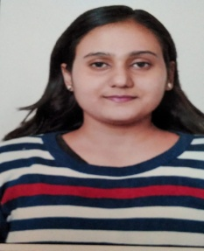

EDUCATION **B.Tech**

Maharaja Surajmal Institute of Technology 2017 - 2021

CGPA: 9.20/10

# Senior Secondary (XII), Science

Bijnor Public School (CBSE board)

Year of completion: 2017 Percentage: 90.00%

# Secondary (X)

S.T. Mary’s School (ICSE board)

Year of completion: 2015 Percentage: 95.60%

POSITIONS OF RESPONSIBILITY

Head Leader of Music Club of College ORGANIZER OF ICAIA'20.

TRAININGS **Android App Development** Internshala Training, Online Jul 2020 - Present

Done Android App Development training from Internshala. It has been a great learning experience and I am further improving my skill.

**Data Structures And Algorithm** Coding Mafia, Coding Club India, Online May 2020 - Jun 2020

I did Online Course from Coding Mafia on DSA . I am right now improving my command over the subject further.

# JAVA(core)

Insta Infotech, Delhi Jun 2019 - Aug 2019

I have learned Core Java from the Institute.I have used my knowledge in implementation of my Project(Online Voting System).

# C++ Language

Insta Infotech, Delhi

PROJECTS **Online Voting System**

Jul 2019 - Aug 2019

The project is based on online Voting.

The person can cast his/her vote by adding required information. Total number of votes casted will be visible to the admin.

For security purpose a unique code is given to every individual .

SKILLS **Java**

Intermediate

# C Programming

Intermediate

# SQL

Intermediate

# HTML

Intermediate

# Kotlin

Beginner

# C++ Programming

Intermediate

# Python

Beginner

ADDITIONAL DETAILS Interested in Reading,Travelling and music.

College I’d Card