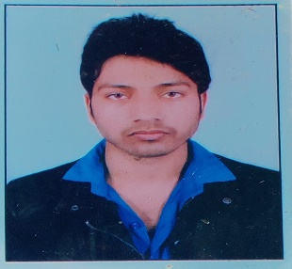

**ANKIT VERMA**

Akbarpur bahlolpur sandila Uttar Pradesh Pin code -241201

+91**-**7526041615

Ankitverma7526@gmail.com

**Academic Background**

|  |  |  |  |  |
| --- | --- | --- | --- | --- |
| **S.No** | **College/School** | **University/Board** | **Year of Passing** | **% or Grade** |
| B.Tech (CSE) | Galgotias University | UGC University | 2021 | 8.86(till date) |
| 12th Class | SKD Academy | ICSE Board | 2016 | 69.00% |
| 10th Class | SKD Academy | ISC Board | 2014 | 71.00% |

**Technical competencies**

* **Programming Languages :** C/C++, Python, Java(Basic), HTML, CSS,
* **Database :** SQL

**Personal competencies**

* Quick learner
* Well disciplined
* Communication
* Being Punctual

**Academic projects**

* **AVIS System-**Automatic vehicle identiﬁcation and recognition system is an autonomous technique applied in traﬃc system including electronic toll collection, border and custom checkpoints, etc. With hardware like camera, the system can recognize each unique vehicle correctly and quickly. As the most important part, automatic license plate recognition(ALPR) is one form of the vehicle identiﬁcation.
* **Online Libarary Management System –**A library management is a project that manages and stores books information electronically according to students needs.,(3rd year)

**Seminars/Certifications**

* **English Score certificate from British Council**
* **Certificate of introduction to cyber security from CISCO**
* **Certificate of Introduction to Html from COURSERA**
* **Certificate of Step into Robotics Process Automation from GUVI**
* **Certificate of Python and c language from UDEMY**

**Achievements**

* Race competition winner during School
* Dance competition winner during School
* Art competition winner during School
* Class coordinator (CR) and Placement Coordinator

**Co- Curricular Activities**

* Participation in an **online workshop on Data Structures Heap.**
* Participate in Product Launch competition.
* Participation in Online workshop of Skycampus digital knowledge

**(ANKIT VERMA)**