CURRICULUM VITAE

Pramod Kumar 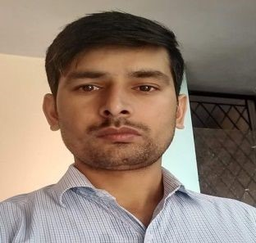

F-2, School Road, Khanpur
New Delhi-110062
Contact no. 8800685802
Email-pkpromadkumar123@gmail.com

CARRIER OBJECTIVE

I would like to pursue my career in an esteemed organization where I can implement my skills, knowledge and intelligence. And make myself perfect and stable with continuous learning and self-development and achieve the highest pinnacle of success with determination and hard work.

EDUCATIONAL QUALIFICATION

- B.A. Passed from A.U.Faizabad
- 10th​ ​ Passed from U.P. Board Allahabad

- 12th​ ​ Passed from From U.P. Board Allahabad
- Diploma in Computer Application ( 1 year course)

WORK EXPERIENCE

- Worked May 2013 to August 2015 in FMCG-Dabur India Pvt LTD. Distributer Point Mahipalpur

- Worked August 2015 to May 2018 in GSK (Glaxo smith Kline) distributor point in mahipalpur

- Worked May 2018 to July 2019 in Gopal ji dairy food products Pvt ltd as a Sales officer.

- 6 month worked Moon Beverages Ltd. As a Sales supervisor From October 2019 ​ February 2020
- Currently working (TOPS) GD FOODS MFG (INDIA) PVT LTD as a sales officer from march 2020 to till now

Handling team and his quarry
- Handling Primary & Secondary sale
- Handling Distributors
- Handling Promotional Sales And Retail Sales Also

PERSONAL INFORMATION

❖​ Father’s Name | : | Shri Kamal Kishor Tiwari
❖​ Date Of Birth | : | 29/11/1989
❖​ Gender | : | Male
❖​ Nationality | : | Indian
❖​ Marital Status | : | Married
❖​ Hobbies | : | Reading Books, Playing Cricket
❖​ Languages Known | : | English, Hindi
❖​ Strengths | : | Smart working, Honest and Friendly Nature

DECLARATION

I hereby declare that all the information furnished by me is correct and complete to the best knowledge and belief. I shall be great fully if you given an opportunity to work in your company. Thanking You.

Dated:- ____________

