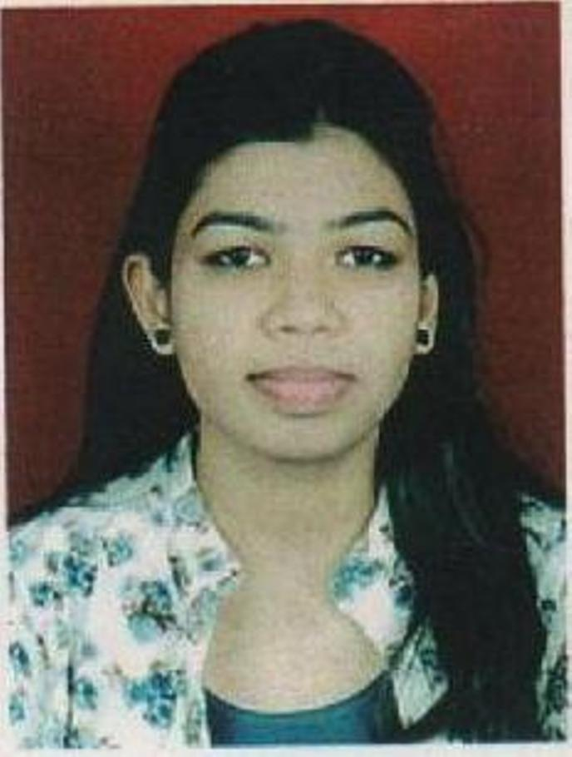

**HARSHADA .R. THULE**

Wakad,Pune 411057

**Contact no:**+91 8237867387

**Email ID:** harshada.thule@gmail.com

**Sub Domain**: <https://harshadathule.com/>

**My Background:** I Develop implement and oversee the online marketing strategy for organizations.I create and execute digital marketing campaigns and web content.

**Experience:**

**2019**:

* 4 Months Training experience as a Trainee **in Digital Marketing from Lipsindia** Institute in Wordpress , Google Adwords,Social Media Marketing, Search Engine Optimization, Google Analytics and Google Tag Manager

**2020**:

* Currenty working as **Digital Marketing Executive**

**Company**: Yes Homes Real Estate Company,Wakad,Pune

**Educational qualifications:**

**2019:**

* Digital Marketing Certification Course
* **Institute:** **LIPSINDIA** (PUNE)

**2014:**

* **Education:** Bachelor of Engineering in Electronics
* **Institute:** G.H. Raisoni College Of Engineering, Nagpur

(An Autonomous Institute under UGC act 1956)

* **Branch:** Electronics and Telecommunication
* **Aggregate:** 64.44%(First division)

**2009:**

* Maharashtra State Board , HSSC
* **Score :**65.33% (First division)

**2007:**

* Maharashtra State Board ,SSC
* **Score :**70% (First division)

**Skills:**

* Google Adwords , Lead generation , Social Media Marketing , Search Engine Optimization , Google Analytics,Creating Websites in Wordpress,Google Search Console,Facebook Campaign

**Skill sets:** I can handle projects efficiently and work well as good team member expressing ideas, solving problems, setting goals, making decisions, coordinating tasks, managing groups, and managing time

**Hobbies:**

* Net Surfing,playing badminton, sketching drawing,dance

**Personal detail:**

Date of birth: 16th oct 1991

Father’s name: Mr. Rajendra Wasudeo Thule

Mother’s name: Mrs. Sangita Rajendra Thule

Address: plot no.52 khushi nagar, near ring road, jaripatka, Nagpur – 440014

Gender: Female

Marital Status: Unmarried

Nationality: Indian

Languages Known: English, Hindi, and Marathi

**Declaration:**

I hereby declare that the above given information is true to the best of my knowledge and belief.

**Date:** / /2020 

**Place:** Pune (Harshada Thule)