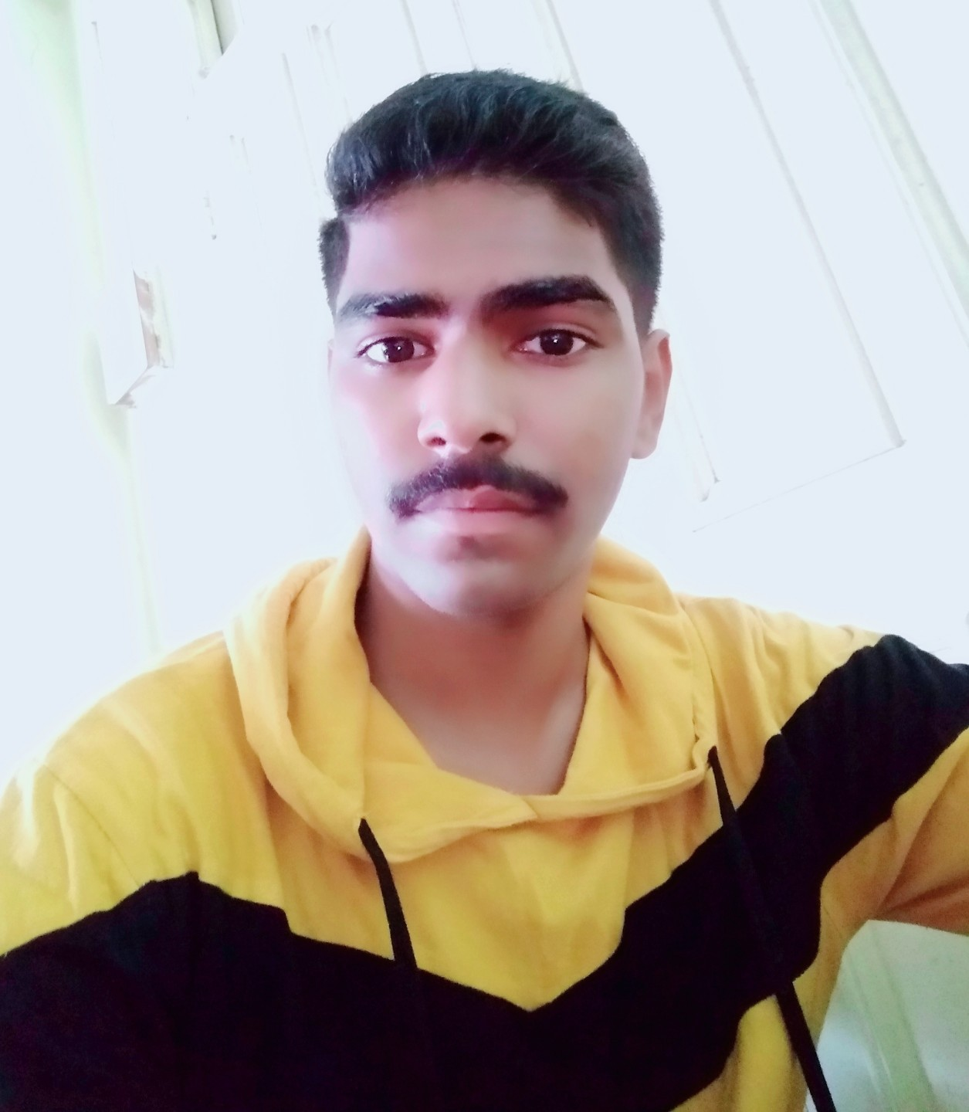



Amity School of Applied Sciences, Mumbai

MUSHTAQ.MAHBOOB ALI.SHAIKH

1414, floor 14, Rehab building no 1,behind bharni naka,

Antop hill,Wadala East, Mumbai-400037

Contact: +91-9769300708

E-mail: mushtaqshaikh140@gmail.com

**____________________________________________________________________________________**

**Career Objectives:** To achieve high career growth through a continuous learning process and keep myself dynamic, visionary, and competitive with the changing scenario of the world.

|  |  |  |  |
| --- | --- | --- | --- |
| **ACADEMIC CREDENTIALS:** | | | |
| **Qualification** | **Institution/University** | **Percentage/CGPA** | **Year** |
| Msc (Applied Chemistry) | Amity University Mumbai | - | 2020-2022 |
| Bsc (Chemistry) | Bhavans Hazarimal Somani College affiliated to Mumbai University | 6.78 | 2017-2020 |
| HSC (Science) | Elphinstone technical high school and jr college | 62% | 2015-2017 |
| SSC | Worli Seaface Municipal English School | 74% | 2015 |

|  |
| --- |
| **SKILLS** |
| Strong motivational and leadership skills  Ability to produce best result in pressurized situation.  Excellent analytical skills  Good communication - writing and oral skills  Qualitative and quantitative testing  Ph metery  Water testing (e.g. PH,DO, BOD, COD, TSS, TDS)  Spectroscopy method  Conductometry & Potentiometry titration |

|  |  |
| --- | --- |
| **WORK EXPERIENCE** |  |
| **Completed 45 days Internship of (Scope and Application of Fermentation in Industrial) by Haldia University Collaborate with Ankur biochem Pvt Ltd.** |  |

|  |
| --- |
| **COMPUTER LITERACY**: |
| MS Office (Word, Excel, PowerPoint) |

|  |
| --- |
| **LINGUISTIC PROFICIENCY**: |
| * English * Hindi * Marathi * French |

|  |
| --- |
| **INTERESTS** |
| * Reading story * Exploring new places for food and shopping * Listening music * Playing football |

# Other Personal Details

Father’s Name : Mahboob Ali Shaikh

Date of Birth : 25th May 1999

Nationality : Indian

PAN Card Number : JKFPS9191J

Marital Status : Single

# Declaration

I hereby declare that all the above written information is correct to the best of my knowledge and belief.

Date : 14th March 2021

Place : Mumbai Signature

Mushtaq. shaikh