SASIDHAR GUNTURU
An experienced and proven leader with program management expertise in developing software solutions meeting client business objectives to achieve profitable growth.
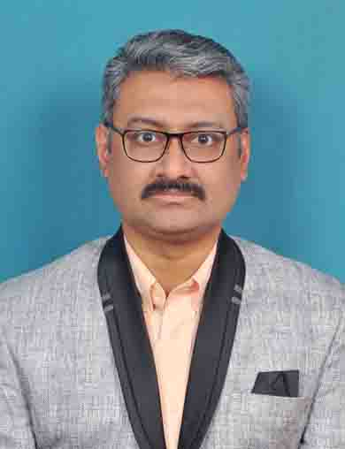
E-Mail: gunturu.sasidhar@gmail.com; gunturu.sasidhar@live.com Mobile: +91-86398 16180
LinkedIn: https://www.linkedin.com/in/sasidhargunturu/

SUMMARY

- A result-oriented professional with over 22 years of experience in:
~ Project Management ~ Client Engagement ~ Delivery Management
~ People Management ~ Stakeholder Management ~ System Development & Implementation
~ Escalation Management ~ Operations Management ~ Incident Management
- Acting COO and Contracted Project/Delivery Management role for account and delivery management of a 1.5M$ account where all the details are accounted for and strategy of the account co-directed by me.
- Expertise of working in 24x7 mode for running programs for clients primarily based out of USA in the Risk Reward Engagement Model for their proprietary products and services.
- I have the distinction of working with marquee clients like Cisco, IBM, Xerox, Teradyne, NGC UK, Southern State Grids of India, China Light and Power, and with internal HPC CoE of HCL for embedded applications.
- Proven abilities of working as an On-site Co-ordinator and Delivery Manager adhering to CMMi practices, proprietary products with a passion for coaching, mentoring.
- Skilled in handling end-to-end development projects from inception, requirement specs, planning, designing, implementation, configuration management, documentation and closure with cross-cultural teams in UNIX & C environments.
- Hands-on experience in project management methodologies Agile Scrum, Waterfall, DevOps.
- Resourceful in providing business value to the client and maintaining close working relationships with key clients / accounts

PROFESSIONAL EXPERIENCE

Feb ’18- Present FINSOL Consultancy Pvt. Ltd, Visakhapatnam Acting COO/Contracted Project Manager
(www.finsolconsultancy.com)
Aug’04 – Nov’15 HCL Technologies Ltd., Chennai/Bangalore Project Manager Engineering Services
(www.hcltech.com)
Apr’00 - Jan’04 GE Power Services (India) Pvt. Ltd., Hyderabad Systems Analyst
(www.ge.com/in/ge-power-india-limited)
Oct’99 – Mar’00 AppLabs (India) Pvt. Ltd., Hyderabad Systems Analyst
(www.valuelabs.com)
Oct’96 – Sep’99 CMC Ltd., Hyderabad Systems Integrator
(cmcltd.com)

CORE COMPETENCIES

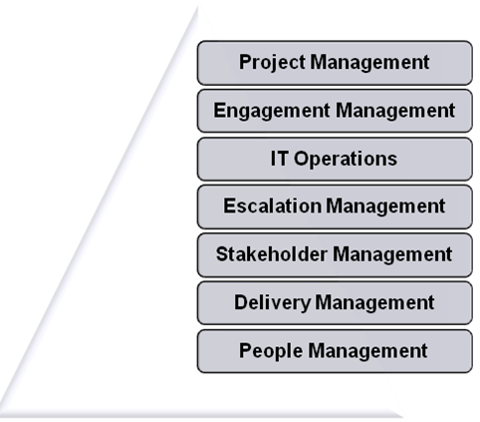
- Project Management: Designing and developing project architectures; monitoring and controlling projects with respect to cost, resource deployment, time over-runs and quality compliance to ensure its satisfactory execution. Monitoring development activities and conducting timely risk assessment & mitigation.
- Engagement Management: Leading with the COO role for a large client for MIS reports, Strategy for Business Development, Strategy for Account Management, Resources’ onboarding, Staff Management, Coaching,
- IT Operations: Incident Manager handling the engineering stage of escalation for incidents to be resolved within the agreed Service Levels
- Stakeholder Management: Assessing client requirements & mapping them to business solutions; involved in project planning, effort, design, scope, estimation, resource coordination and delivery, as per specified time frames
- Stakeholder Management: Mapping client’s requirements, attending / conducting business user meeting, project planning & scheduling providing them customized business solutions
- Delivery Management: Establishing process setup and monitoring the implementation; conducting phase gate reviews, debugging and troubleshooting the application and executing complex projects in close collaboration with management, customers and stakeholders
- People Management: Managing a team of 40+ Engineers, deliverables as part of maintenance release schedule, major release schedule, hot patches, debug/instrumented binaries
- Scrum Master: Directing and leading the technical personnel; imparting continuous on job training to the workforce for accomplishing greater effectiveness / efficiency.

ACCOMPLISHMENTS

Finsol Consultancy (Acting COO, Project/Delivery Management)
- Grew Business from 1 Million USD to 1.5 Million USD in a year by inculcating engineering practices in Delivery.
- Leadership in handling non-software project issues like regulatory compliance, documentation, implementation
- Grew the skill set of engineers in stakeholder management, as reflected in getting managed services delivery in projects.

GEHC Project (ScrumMaster, People Management/Delivery Management)
- BDD oriented Agile Scrum team’s delivery, leading a distributed, cross-vendor 15-member Agile team & handled work encompassing on-boarding, daily standup, trainings & delivery.
- JIRA, ALM, Software Impact Analysis are the main scrum artifacts.

CISCO Project (ScrumMaster, People Management)
- Reduced average escalation resolution time from 72 hours to 48 hours for the Fortune 50 client by effective utilization of resources, did functional reorganization by segregating escalation and sustenance teams
- Essayed a stellar role in taking project monitoring using Rally initiatives to execute projects on time and within budget
- Actively suggested enhancements like script based archives to improve the application performance during archiving

Xerox/Teradyne/IBM (Individual Contributor, People Management/ Delivery Management)
- Essayed a stellar role in turning around the Process Compliance Index for various delivery programs. I have driven the fine tuning of the process compliance for engagements with the US based clients – Teradyne, IBM, Xerox

NGC, UK, SCADA Projects (Individual Contributor, Stakeholder Management)
- Successfully implemented Safety Management System, for NGC Power Grid UK, which enables the XA/21 scada product to understand the state of maintenance of electrical equipment.
- Merit of co-writing the first embedded application program for FEP in SCADA implementation that ran at 3 Load Dispatch Canters in 24x7 mode for more than 5 years without any unscheduled outage (This FEP was responsible was data collection unit with a 2-second interval refresh for the entire state of undivided Andhra Pradesh. That is about 50+ RTU’s handling about 2K data collection points. In addition to data collection the supervisory control of electrical equipment was also mandated with a 1 sec response time.)

AppLabs (now ValueLabs) (Individual Contributor, People Management)
- Gained expertise in negotiating with prospective clients for requirements elicitation, business development with known handicap of lesser technical knowledge helped AppLabs grow from being from a start-up to a SME (20 FTE to 30 FTE).

Detailed Projects in the Annexure Page.

EDUCATION

- B.E. in Electrical Engineering from Bhilai Institute of Technology, Pt. Ravi Shankar Shukla University
- Advanced Diploma in Software Engineering from APTECH, India

Certifications:

- ITIL v3 Foundation Certified from APMG
- PMP® Certified from Project Management Institute, PA, USA
- Agile Scrum Master from International Scrum Institute
- DevOps Generalist Certificate from International DevOps Certification Academy www.devops-certification.org

TECHNICAL SKILLS

Operating Systems: Android, DEC-Unix, Solaris
Languages/GUIs: C, C++, SQL, COBOL, VB6, Android
RDBMS: MS-SQL, Oracle 7.X/8.X, DB2, MS Access2000
Protocols: DNP3, BBC-Indactic 8088
Hardware Testing: IBM’s Maui, Cannavaro Blades (P6 Blades)
Quality: PCI audits as per CMMi model for delivery projects
Tools: MS Project, Rally (Agile), MS Office Suite, Internal Tools for Bug Tracking

PERSONAL DETAILS

Address: E-411, Palace Heights, Sivaji Nagar, Kurmannapalem, Aganampudi, Visakhapatnam, 530046
Languages Known: English, Hindi and Telugu
ANNEXURE

GEHC client – (Delivery Management as an onsite Project Manager/ScrumMaster)
- Plan and execute the project onsite, planning and monitoring in terms of resource, effort, budget, infrastructure, risks.
- BDD based Agile Scrum teams delivery was oriented by the use of Jbehave, Junits for the Core Java code.
- Distributed Agile team of 15 different-vendor FTEs dealing with on-boarding, daily standup, trainings, delivery as the main responsibilities.

Cisco client – (Program/Delivery Management)
- This client is reaching its 2-decade association with HCL. Accountable for large engagement which started in fall of 2012
- Served as a Program/Delivery Manager for applications components of the 3-tier product
- Handled the delivery of major/maintenance releases in agile model and handling escalations for a 24x7 support.
- Achieved on-schedule delivery of the releases and also kept all the stakeholders informed on weekly basis on the progress of the team of 20+ folks.

Xerox Engagement – (People Management)
- Xerox is about half a billion dollar engagement with about 1000 FTE’s spread over 5 years
- Served as a Program Manager in Xerox FFPS Hardware Integration engagement
- Worked primarily in the people management role with the following challenges
- Re-badged Xerox Employees into HCL payroll
- Flexible work timings
- Option for work from home
- Attrition
- Served as a lead in the PMO for one of the 4 streams (Board design and FPGA) in Xerox and accountable for:
- Project Management Plan (for board design and FPGA)
- New Process Definition to map the Xerox’s process to HCL’s process
- Responsible for the monthly PCI score for the process related definition of the Brilliance project in Discovery stream

VLSI – (Individual Contributor)
- Worked as an individual contributor as a Delivery Manager and accountable for:
- Conducting quarterly POWER review with the BUH (AVP) with the Delivery Unit Head also participating – Have to prepare the entire slideshow individually
- Improving margins and the plan for the same
- Handling the multiple process aspects of this million dollar T&M project with HP as per the CMMi practices.
- Conducting Process Compliance audits, maintaining PMP, PMWB and other QA process related artifacts of the project as per CMMi process definition.
- Turned around the PCI score from RED state to GREEN in about 2 monthly audits

TechCEED – Training Academy Head (Stakeholder management)
- Established the process for facilitating technical trainings for the entire DU
- Reported directly to the BUH (AVP) and formulating strategy to elicit the training needs in advance based on the projects funnel of all the projects
- Conducted many seminars as part of Project Management Academy trainings

Embedded Technologies (Android) – (Individual Contributor)
- Instrumental in developing a prototype Building Management System (mini-SCADA) using an open source Android Stack – Successfully demo’ing the same in Jan 2011 CE show in Las Vegas
- Pivotal in the development of control center using Android Stack and the application front-end by using the Android Application Programming Framework.
- Worked on various technologies like CUDA, Grid Technologies, Android – I was involved in Grid Technologies and Android. We established a CoE for all these technologies and had a billing target of 100% for the entire team of 10+ team.

IBM Blades Testing – 2+ years (Individual Contributor and People Management)
- Led for the group of more than 8 FTEs for this technical group wherein I was also the on-site coordinator.
- Served as a People Manager to manage the following aspects - Conflicts of interest with the customer at the on-site premise and Stakeholder management
- Carried out the testing of the BIOS level adherence to standards of the various IBM P5/P6 blades.

Semiconductor domain – Automated Test Equipment (ATE) – 2+ years (Individual Contributor)
- Served as a People Manager and carried out new projects of the maintenance/sustenance work. I carved out around 3 projects where the billing was higher as against the sustenance work.
- Instrumental in developing of Pattern Debugger code for testing chips using the ATE

SCADA – State wide Electrical Systems Development and Implementation – 8+ years
- Served as a SPOC for all the needs of the client (NGC-UK)
- Power Grid – (NEC) UK – Development of an entire module Safety Management System – description of the same in the accomplishments section of the resume
- Responsible in all phases of the project from requirements elicitation to implementation and sign-off for SCADA project for GE Power Systems India Ltd. and also while in CMC
- AP State (A southern state in India)– co-Development and Lead in development and Implementation of OSKER and DEFT modules of CMC’s SCADA solution which was superseded by GE’s XA/21 implementation, a feature of Safety Management System for XA/21 co-developed by me.

