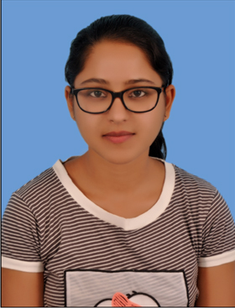
MEDHA SHUKLA
Central University of Jharkhand

C/O. Mr. Basant Kumar Shukla

Panki Road, Baralota,

Tapeshwari Ashram Campus,

Daltonganj-822101, Jharkhand Ph: 8789188394 medhashukla30@gmail.com

OBJECTIVE
My objective is to work with full dedication and enthusiasm in the field of media industry and enrich my skills and experiences.

Academics
Indian Certificate of Secondary Education (ICSE), X  Central Board of Secondary Education (CBSE), XII  Bachelors of Arts (Mass Communication) | Sacred Heart School, Daltonganj, 2011  M.K.D.A.V Public School,Daltonganj, 2013  Central University of Jharkhand, 2014-2017 | 78%  84%  8 CGPA

TECHNICAL Skills
MS Office: MS Word, MS PowerPoint, etc.
Typing in English and Hindi
Quark Express
Still Photography and Video making, Adobe Photoshop

SCHOLASTIC ACHIEVEMENTS
Internship project on “ Corporate Communication and Public Relations”, at Steel Authority of India Limited, Research and Development cell for Iron and Steel, Ranchi | (May-June, 2016)
Workshop on “Writing for Media”, at Central University of Jharkhand | 2015
Online Content Writing Internship from IsrgRajan.com | (Dec 2017- Jan 2018)
First Prize (Best Speaker) achiever in Inter College Debate Competition, Rotary Club, Ranchi | 2014
Second Prize achiever in Inter School Debate Competition, D.A.V Public School, Barkakana | 2012
First Prize achiever in Poetry Competition held at Sacred Heart School, Daltonganj | 2009

Other ACHIEVEMENTS
Photography portfolio, Script writing and voiceover in a documentary on “Suicide Among Youths”  Presented paper on “Domination of Mass Media over Folk Media in Society” in the National Conference on “Recent Trends in Management, Humanities and Social Sciences”, organized by Amity University Jharkhand in 2017 | 2016  2017

Area of interest
Anchoring, voiceover, content writing, creative writing, public relations

Extra-Curricular Interest
Reading novels, Article writing, Review development for TV programs, movies and events, Blog writing on Internet and social-network and Poetry composition and recitation.

References
- Dr. Santosh Tewari
Ex-Professor, Centre for Mass Communication
Central University of Jharkhand
Ph: 9852648903

- Dr. Dev Vrat Singh
Dean, Centre for Mass Communication
Central University of Jharkhand
Ph: 9931960785

