ayesha raees  EMAIL  arnayaab64@gmail.com  ayesha raees  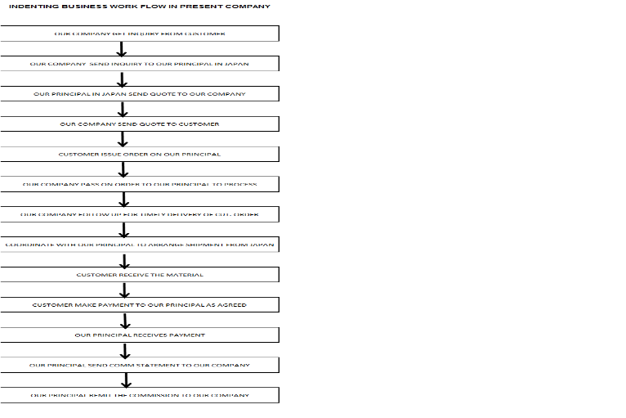  ayesha raees  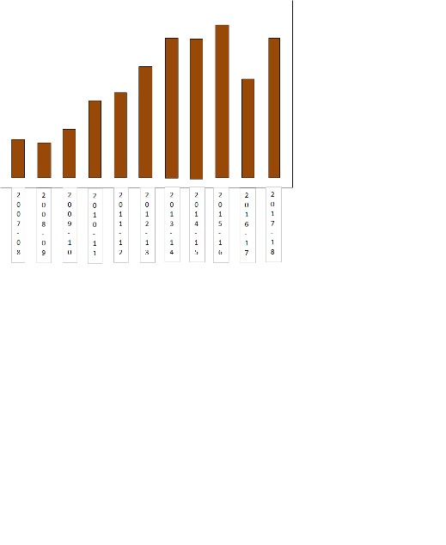  YEARLY GROSS SALARY CHART  ayesha raees | NAME : AYESHA RAEES SHAIKH  D. O. B – 21/07/1983  MARITAL STATUS – MARRIED  FAMILY :  MOHAMMED JAVED MOULA - HUSBAND  FREE LANCE JOURNALIST  ELDER SON : MASTER ABDURRAHMAN – 5 YEARS  YOUNGER SON : MASTER UMAR – 4 YEARS  LANGUAGES KNOWN – URDU , ENGLISH, HINDI, MARATHI
  MOBILE
  8007861498
  Objective
  To be a part of exceptionally hard working, honest, passionate & dedicated team work for world class growth & achievement
  EMAIL
  arnayaab64@gmail.com
  MOBILE
  8007861498
  Objective
  To be a part of exceptionally hard working, honest, passionate & dedicated team work for world class growth & achievement
  Skills
  Hard working, Honest, Passionate, Dedicate to the assignment, Proactive, Ready to Learn new skills, Good Communication & Follow Up Skills, Good in Problem Solving
  EMAIL
  arnayaab64@gmail.com
  MOBILE
  8007861498
  Objective
  To be a part of exceptionally hard working, honest, passionate & dedicated team work for world class growth & achievement
  Skills
  Hard working, Honest, Passionate, Dedicate to the assignment, Proactive, Ready to Learn new skills, Good Communication & Follow Up Skills, Good in Problem Solving
  EMAIL
  arnayaab64@gmail.com
  MOBILE
  8007861498
  Objective
  To be a part of exceptionally hard working, honest, passionate & dedicated team work for world class growth & achievement
  Skills
  Hard working, Honest, Passionate, Dedicate to the assignment, Proactive,
  Ready to Learn new skills,
  Good Communication & Follow Up Skills,
  Good in Problem Solving
  ayesha raees
  EMAIL
  arnayaab64@gmail.com
  MOBILE
  8007861498
  Objective
  To be a part of exceptionally hard working, honest, passionate & dedicated team work for world class growth & achievement
  Objective
  To be a part of exceptionally hard working, honest, passionate & dedicated team work for world class growth & achievement
  Skills
  Hard working, Honest, Passionate, Dedicate to the assignment, Proactive, Ready to Learn new skills, Good Communication & Follow Up Skills, Good in Problem Solving
  Experience
  asst. manager – admin & commercial
  solway international, pune
  23/06/2007 – To Till Date
  Company Profile
  - Representative of M/s. Asahi Diamond Industrial Co, Japan. Asahi has world wide reputation as a leader in quality, performance and consistency as a CBN and diamond products manufacturer like CBN Vitrified Bond Wheels, Roller Dresser, CBN / Diamond Electroplated Wheels, CBN / Diamond Resin Bond Wheels, Diamond Dresser, TA Chip , CPX Reamer, CPX Shoe, Diamond Dies etc
  - Solway doing 2 types of business as follows.
  - Indenting business is Solway International gives technical service of developing engineering products of Asahi Diamond Co. Ltd. Japan in India and Solway International draws commission for the same
  - Trading business is Solway International buying goods from Asahi diamond Industrial Co. Ltd. Japan and Solway International selling to customers at price controlled by Solway International depending on competition.
  Job Profile
  - Tally Accounting
  - Bank Reconciliation
  - Vouching
  - Exchange Gain / Loss working
  - Cash Flow Management
  - Sundry Debtors Creditor Ageing
  - Fixed Asset Register & Depreciation
  - TDS / Advance Tax compliance
  - GST working for sales, purchase input tax credit, RCM,
  - GSTR-1 Returns preparation
  - GSTR-3B Return preparation
  - Sales Tax Assessment
  - GST TRAN-1 Assessment
  - Payroll by Mypay Software
  - Employee Individual Tax Computation
  - PF / PT / / Employee ITR compliance,
  - Due Diligence compliance
  - Sales Administration
  - Co-Ordinate All Back office activities,
  - General Administration
  - Purchase Administration & Coordination
  - Payment Arrangement from Indian Customers to our Principle in Japan..
  Arranging Proforma Invoice for T/T in advance payment
  Arranging Proforma Invoice for LC at sight / LC 90 days
  Confirming LC draft once received from customer.
  - Arranging Import shipment with CEPA from Japan – Air Freight / Sea Freight,
  - Import Clearance – confirming checklist, Confirmation of HSN, arranging customs duty payment,
  - Arranging Export Shipment - Free Trade Sample
  - Liasoning with CHA for forwarding & clearance of shipment
  - Logistics Management
  - Stock Management,
  - Stock Planning
  - Stores Management
  - In House Developed software MAGIC handling for making Invoice, GRN, PO (As we are using Magic instead of SAP, being small Trading company)
  - Worked with software developer to get the customized changes in the software as per our business requirement.
  - GST Invoice preparation
  - Dispatch Management
  - Inter Branch Stock Transfer
  - Leaves, Attendance Management,
  - Insurance systems Marine, Transit, Employee, Godown,
  - Follow up with Software Developer for customization
  - MIS Report related to Management
  - Sales Presentation – Excel, PDF, Power point
  - Exhibition preparation & arrangement,
  - Sales Team Expenses handling
  - Coordination with foreign principal for arranging order & shipment,
  - Sales Back End support & follow up from replying to inquiries till receiving payment
  - Identify, select & develop internal procedure
  - Courier, Printing, Stationary Management
  - Team Management
  sales coordinator
  ferrocare international pune
  01/06/2005 to 20/06/2007
  Company Profile :- Indenting Agents for Japanese leading Manufacturers of CBN Vitrified Bond Wheels, Noritake Co. Ltd., Chuetsu Metal Corporation, Nachi Fujikoshi, Katsuyama, Asahi Diamond ETC
  - Sales Administration
  - Purchase administration,
  - MIS
  - Back office sales support,
  - Co ordinating with 5 Foreign principal for arranging order & shipment
  - Stock planning
  - Stock management
  - Inhouse developed software handling for making invoice
  - Making GRN
  - Sales Presentation in XLS, PDF, Power point,
  INSTRUCTOR
  ALLANA INSTITUE OF INFORMATION TECHNOLOGY
  01/04/2005 to 31/05/2005
  - Education & Training
  - MSCIT course + Internet
  - Medium of Instruction – English / Hindi
  GRAPHIC DESIGNER
  CITY AD AGENCY
  05/11/2005 to 31/03/2005
  - Graphic Designing & DTP in Urdu, English, Marathi, Hindi
  - Commercial Jobs preparation like Visiting Cards, Wedding Cards,
  - Brochure, Posters, Bill Book, Ledger, Challan Book, Voucher Book,
  - Annual Report, Bank Stationery, Souvenir,
  - Typesetting & designing of Books in Urdu, Marathi, Hindi
  - Typesetting & designing of Newspaper – Hindi Fortnightly Rah-e-Mulk,
  - Typesetting & designing of Newspaper Marathi Newspaper – Karya Sheel,
  SUB EDITOR
  HINDI FORTNIGHTLY RAH-E-MULK
  05/11/2005 to 31/03/2005
  - Editing News paper – 8 pages
  - Language Urdu – Paper Font – Deonagiri
  - Writing Articles on local & social issues, Education issues
  - Writing News on basis of press release, press conference
  - Selection of News / National / State Level, Local
  - Proof Reading
  - Selection of Photos, Giving Caption
  - Arranging 1 Page for Women, Children, Islamic Knowledge,
  Soft Articles, Poetry
  - Translation of Important Local News from Local English / Marathi News paper
  accounts assistant
  sahara nagri sahkari pat sanstha
  01/04/2002 to 31/03/2005
  - Daily Scroll Book,
  - Cash Book / Ledger book
  - Cash / Bank / Loan Vouching
  - Loan Register
  - Tally 6,3
  - Daily Account Handling / Recurring Account Handling
  - Fixed Deposit Account Handling
  Education
  JULY 2004
  POST GRADUATE DIPLOMA IN JOURNALISM
  PUNE UNIVERSITY, DEPT. OF JOURNALISM
  ENGLISH MEDIUM / 59.33%
  JUN 2003
  BA (URDU)
  PUNE UNIVERSITY, POONA COLLEGE OF ARTS, SCIENCE & COMMERCE
  MEDIUM OF INSTRUCTINO ENGLISH /64.44%
  JUN 2000
  H.S.C. (SCIENCE)
  MAHARASHTRA BOARD, ABEDA INAMDAR JR COLLEGE
  MEDIUM OF INSTRUCTINO ENGLISH /64 %
  STATE TOPPER & MAHARASHTRA STATE URDU SAHITYA ACADEMY AWARD WINNER – 91%
  JUN 1998
  S.S.C. (URDU MEDIUM)
  MAHARASHTRA BOARD, PMC URDU VIDYA NIKETAN
  MEDIUM OF INSTRUCTINO URDU / 86.80 %
  PUNE DISTRICT – 1ST RANK IN PMC URDU SCHOOLS
  PUNE DISTRICT – 6TH RANK IN ALL URDU SCHOOLS
  JUL 2000
  DIPLOMA IN COMPUTER APPLICATION & MULTILINGUAL DTP
  NCPUL – DECCAN MUSLIM INSTITUTE - 91%
  1ST RANK – MAHARASHTRA / 2ND RANK – ALL INDIA CENTRES
  MAY 2005 – MSCIT - MITCON - 80%
  JANUARY 2018
  DIPLOMA IN GST
  IMAX 4- GST CENTRE
  Skills
  - EXCELLENT COMMUNICATION & FOLLO UP  - SELF MOTIVATED TO PUT EXTRA ORDINARY EFFORTS FOR ACHIEVING 100% CUSTOMER SATISFACTION  - CRAZY IN GIVING THE BEST CUSTOMER SERVICE  - SELF ASSESSED  - PRO ACTIVE, FOCUSED  - PASSIONATE FOR DOING PERFECT JOB  - HONEST, PATIENT, CALM, DOWN TO EARTH  - CO-OPERATIVE, HELPFUL,  - CAN CONTRIBUTE IN TEAM WORK  PERSONAL DETAILS | - KEEN TO LEARN NEW THINGS ANY TIME  - KEEN TO SHARE INFORMATION,KNOWLEDGE WITH COLLEGUE  - PUTTING IMMENSE POWER & EFFORTS IN PROBLEM SOLVING  - TIME MANAGEMENT  - SELF AIMED TOWARDS TARGE ACHIEVEMENT  - TIMELY RESPONSE  - GOOD LISTENER  - GOOD TRAINER AS ATTRIBUTED BY MOST OF THE COLLEGUE

