

## AGE

**30**

SHAILESHKUMAR CHAUHAN

 +91 7435908591

 [shailjesus@gmail.com](mailto:8866519040vicky@gmail.com)

## CAREER OBJECTIVE

I want to spend career in an extremely vibrant, stimulating and challenging work environment, where my analytical and technical ability get nourished.



# Education

**B.A** Graduated

Bombay Vidhyapith 52%

Second class

**Hardware & Networking** 80%

Jetking Institute Distinction

**H.S.C** 50%

G.S.H.E.B Second class

**S.S.C**  73%

G.S.E.B Distinction



# Skills

* Fast Learner • Time Management • Self - Motivation
* Decision Making • Leadership • Positive attitude
* Team Work • Communication



# Work Experience

* Work experience: 4 years

## Computer Co-Ordinator

NIIT Pvt Ltd

Ahmedabad

* 1 year

Self Employee as a Computer operator

* Right now i am working as a **Computer Admin** in Shanti niketan kid's care.



# Computer Proficiency

* + Operating system xp, win 7, win 8, win 10
  + Ubuntu operating system
  + Microsoft Office
  + internet

# Languages

* + English
  + Gujarati
  + Hindi



# Personal Interests

* + Photography • Listening Music • Travelling



# Personal Details

|  |  |  |  |
| --- | --- | --- | --- |
| Father’s Name: | Mr. Jasubhai Chauhan |  |  |
| Marital Status: | Married |  |  |
| Gender: | Male |  |  |
| Religion: | Christian |  |  |

|  |  |
| --- | --- |
| Nationality: | Indian |

**Declaration**

I, Shailesh Chauhan, hereby declare that the information contained herein is true and correct to the best of my knowledge and belief.

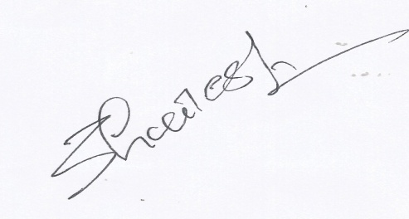

Shailesh Chauhan

Ahmedabad, Gujarat